AMIS SIG Introduction Microservice Choreography with Docker, Kubernetes Node.js and Kafka –Hands-on

1st June 2017

The ultimate goal of this workshop is to achieve microservice choreography. We will get there by implementing microservices as Dockerized Node.JS applications that run on Kubernetes and leverage microservice platform facilities such as a cache and an event bus. This event bus (Apache Kafka) provides the backbone for the choreography that will have microservices participate in a dance that no one orchestrates.

You will go through a number of steps in this workshop – that have you work with (and install) Docker, Kubernetes, Redis, Node.js, Apache Kafka and MongoDB.

You can get access to the sources for the practices from the GitHub repository: <https://github.com/lucasjellema/microservices-choreography-kubernetes-workshop-june2017> .

# 1. Prepare a local Kubernetes and Docker environment

We will work with Docker in this workshop. You will be running multiple Docker Containers and have them interact. Subsequently, we will be using Kubernetes and its minikube cluster.

## Installation

The installation we have to do before getting started with this workshop depends a little on your operating system – and of course the software you may already have set up on it. What we need to work with is at least:

* Docker
* VirtualBox
* Kubectl
* Minikube
* Moba Xterm

On Windows and MacOS – without native support for Docker – we also need Docker Toolbox (or a VM running Linux) and MobaXterm (or another SSH client).

### Windows and MacOS: Docker Toolbox and VirtualBox

I will assume an older version of Windows or MacOS that does not have native Docker support. If that is your case, You need to:

* Download & Install the latest [Docker Toolbox](https://www.docker.com/products/docker-toolbox) (this is not the same thing as just installing Docker)
* Download & install [VirtualBox](https://www.virtualbox.org/wiki/Downloads) for Windows or OS X. Direct link to the binaries [here](http://download.virtualbox.org/virtualbox/5.1.14/VirtualBox-5.1.14-112924-OSX.dmg) (minikube relies on some of the drivers)

VirtualBox: go to the VirtualBox Downloads page: <https://www.virtualbox.org/wiki/Downloads> . Download the latest installer for Windows or MacOS. Run the installer to install VirtualBox.

Docker Toolbox: <https://docs.docker.com/toolbox/toolbox_install_windows/> or <https://docs.docker.com/toolbox/toolbox_install_mac/> (the steps: download the installer, run the installer, run the Docker Quickstart Terminal window to create the *default* machine)

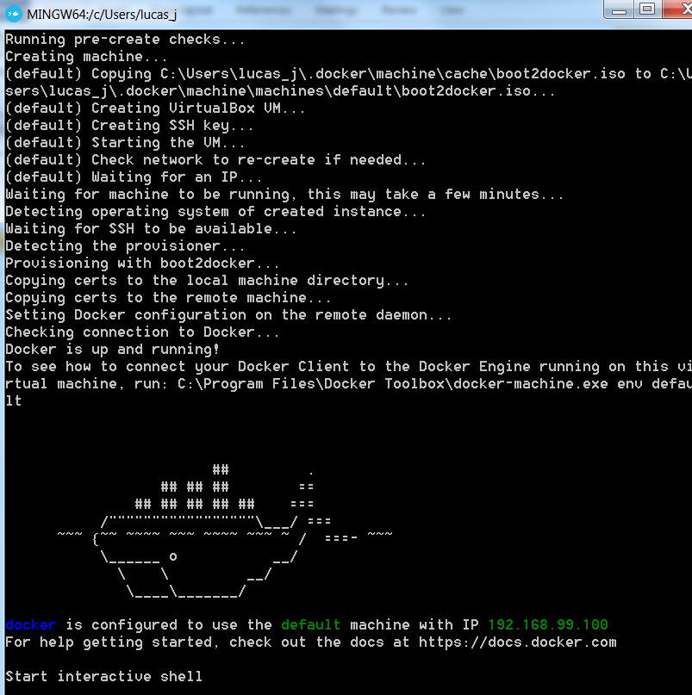

### Linux: Docker and VirtualBox

If your operating system is Linux to start with, you still need to install Docker and VirtualBox as well as Kubectl; you do not need Docker Toolbox.

Go to <https://www.docker.com/community-edition> and get the installer for your Linux distribution. Run the installer to set up Docker in your environment.

VirtualBox: go to the VirtualBox Downloads page: <https://www.virtualbox.org/wiki/Downloads> . Download the latest installer for Linux. Run the installer to install VirtualBox.

### Install Minikube and Kubectl on all operating systems

For Minikube and Kubectl – follow instructions at <https://kubernetes.io/docs/tasks/tools/install-minikube/>. These involve the installation of *kubectl* and *minikube*. The

* kubectl from
  + MacOS: <http://storage.googleapis.com/kubernetes-release/release/v1.4.0/bin/darwin/amd64/kubectl>
  + Linux: <http://storage.googleapis.com/kubernetes-release/release/v1.4.0/bin/linux/amd64/kubectl>
  + Windows: <http://storage.googleapis.com/kubernetes-release/release/v1.4.0/bin/windows/amd64/kubectl.exe>
* minikube from <https://github.com/kubernetes/minikube/releases>

### Some resources:

Tutorial : Getting Started with Kubernetes on your Windows Laptop with Minikube - <https://rominirani.com/tutorial-getting-started-with-kubernetes-on-your-windows-laptop-with-minikube-3269b54a226>

<https://codefresh.io/blog/kubernetes-snowboarding-everything-intro-kubernetes/>

Minikube on Windows7: <https://quip.com/1TYDAdJowAgJ>

Running Kubernetes Locally via Minikube - <https://kubernetes.io/docs/getting-started-guides/minikube/>

Kubernetes Cheat Sheet: <https://kubernetes.io/docs/user-guide/kubectl-cheatsheet/>

## Run Minikube Single Node Cluster

To run minikube – and have the one-node cluster initialized (in a VirtualBox VM):

minikube start

(minikube start --insecure-registry localhost:5000)

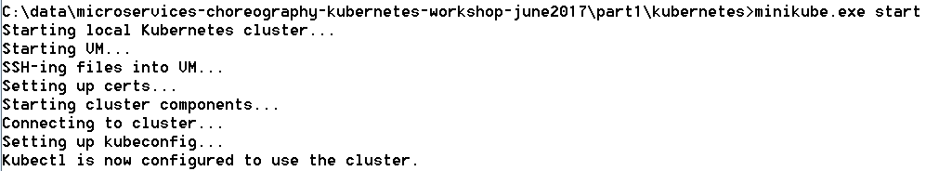

minikube dashboard --url=true



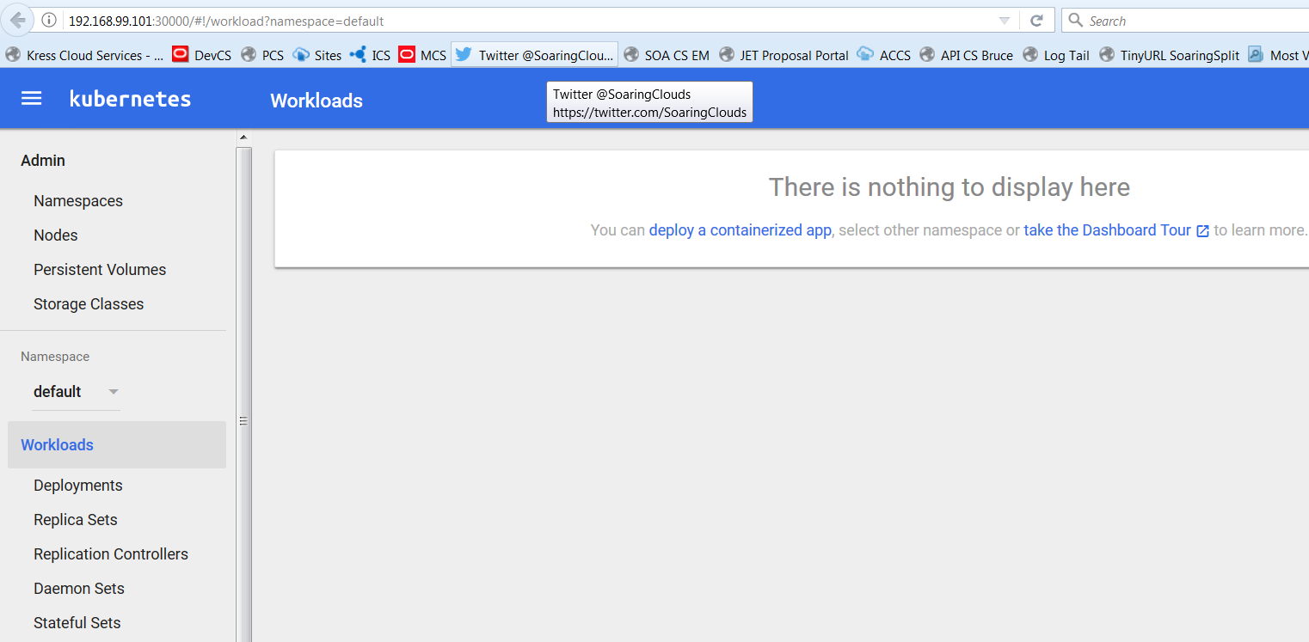

minikube status



To get the IP address of the Minikube cluster:

minikube.exe ip



To check on the nodes of the cluster, we can do:

kubectl.exe get nodes



Test connect into the minikube VM through an SSH session:

The IP address was retrieved above. The port to use is 22 and username is *docker*, password is *tcuser*.

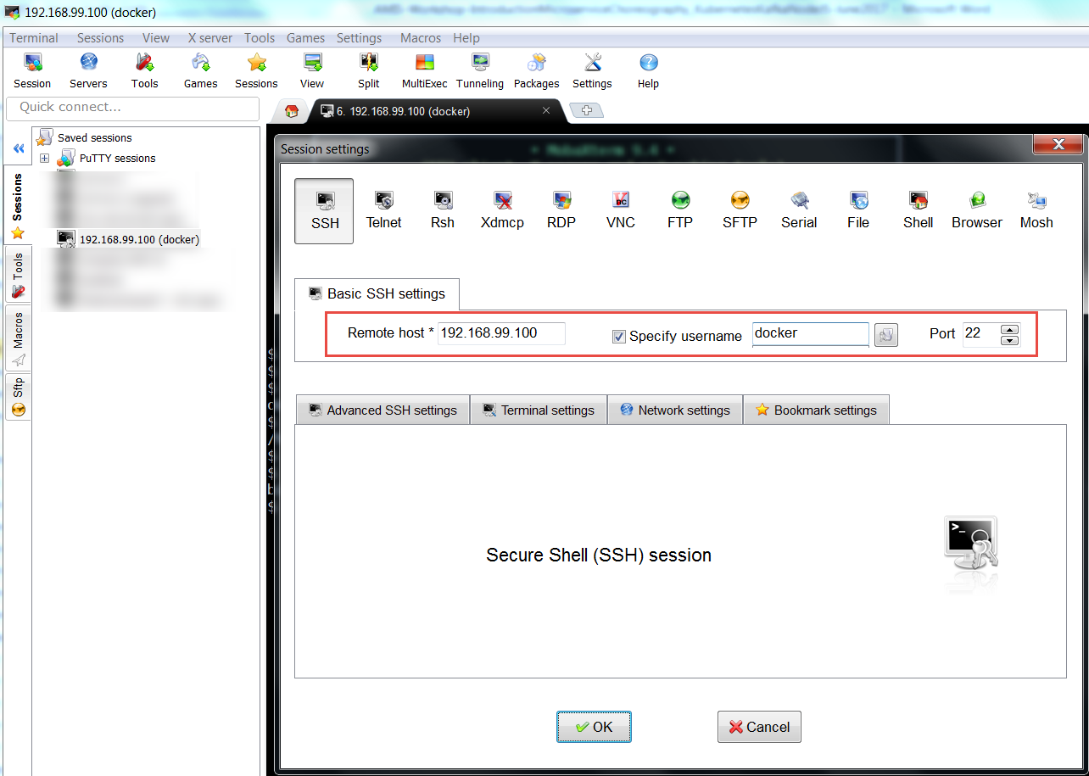

Note: after running for the first time, a new VM called minikube will show up in the Virtual Box GUI.

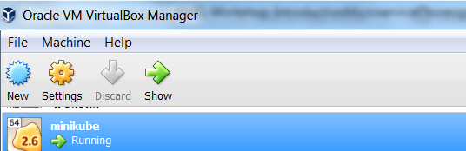

When the minikube cluster is down – minikube stop – you can configure this VM definition, for example to add shared folders:

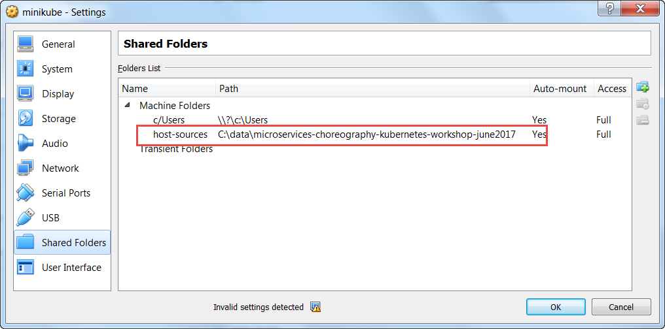

That can be accessed later on in an SSH session:

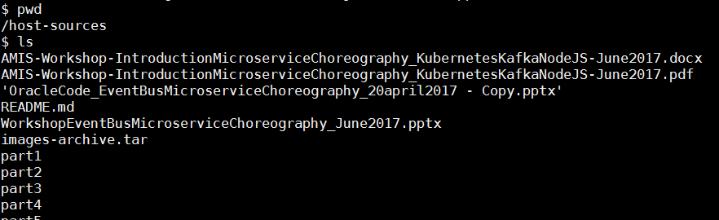

### Run Something on the MiniKube Cluster

Now in order to run a first [Docker container image in a Kubernetes] Pod on the cluster:

# deploy Docker container image nginx:  
kubectl run my-nginx --image**=**nginx --replicas**=**2 --port**=**80

  
A Pod is started on the cluster with a single container based on the nginx Docker container image. Two replicas of the Pod will be kept running.

# as the result of the above, you will see pods and deployments  
kubectl get pods  
kubectl get deployments

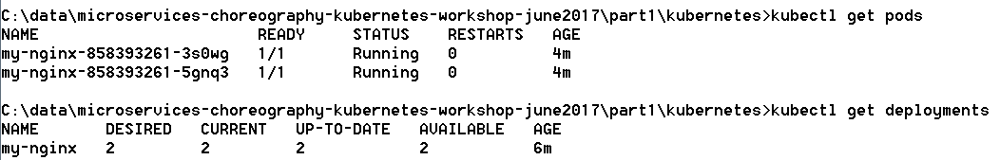

In the Dashboard:

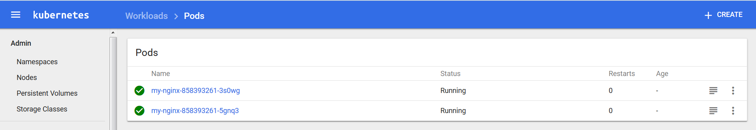

At this moment, the my-nginx containers cannot be accessed from outside the cluster. They need to be exposed through a Service:

# expose your deployment as a service  
kubectl expose deployment my-nginx --type=NodePort



# check your service is there  
kubectl get services



And in the Dashboard:

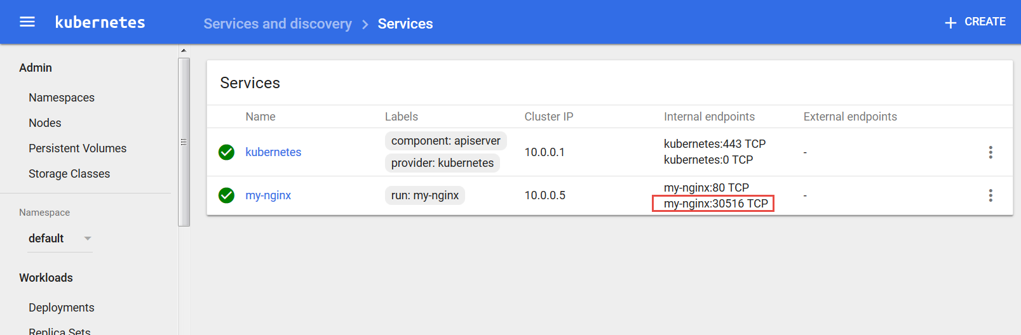

# Access your service from your default browser  
minikube service my-nginx

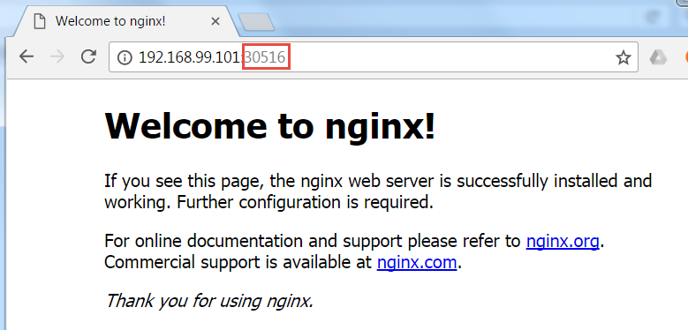

If you are interested in the logging from one of the Pods, you can get to that logging in the dashboard. From the Services tab, drill down to a specific Service. Then click on the icon for the Pod that you are interested in:

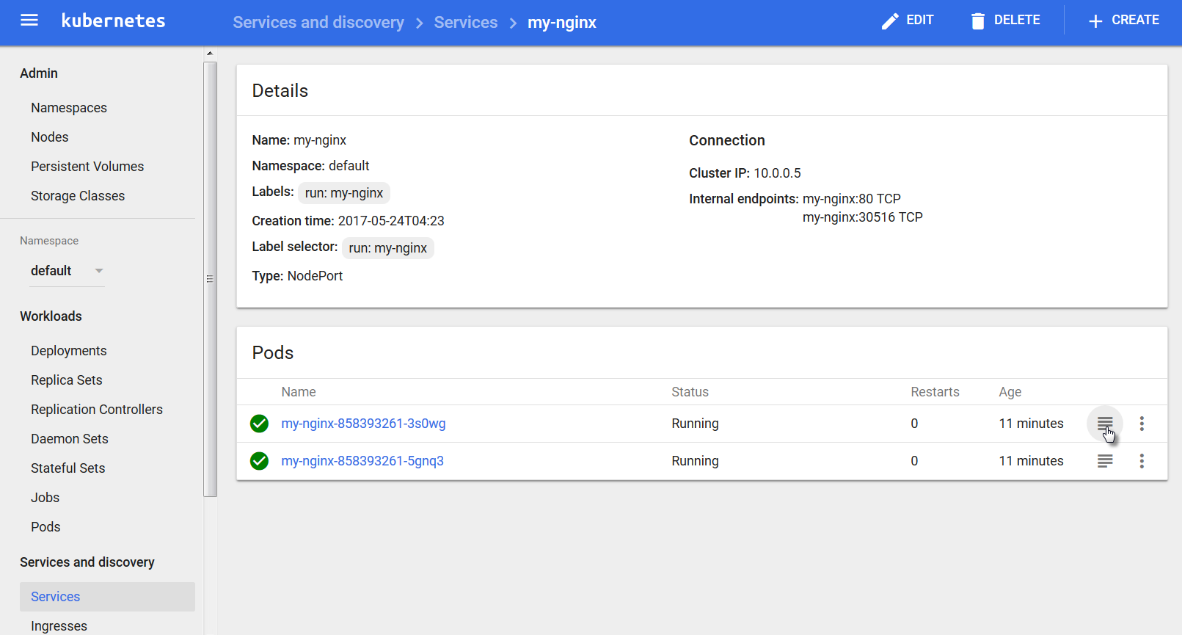

The logging will be shown:

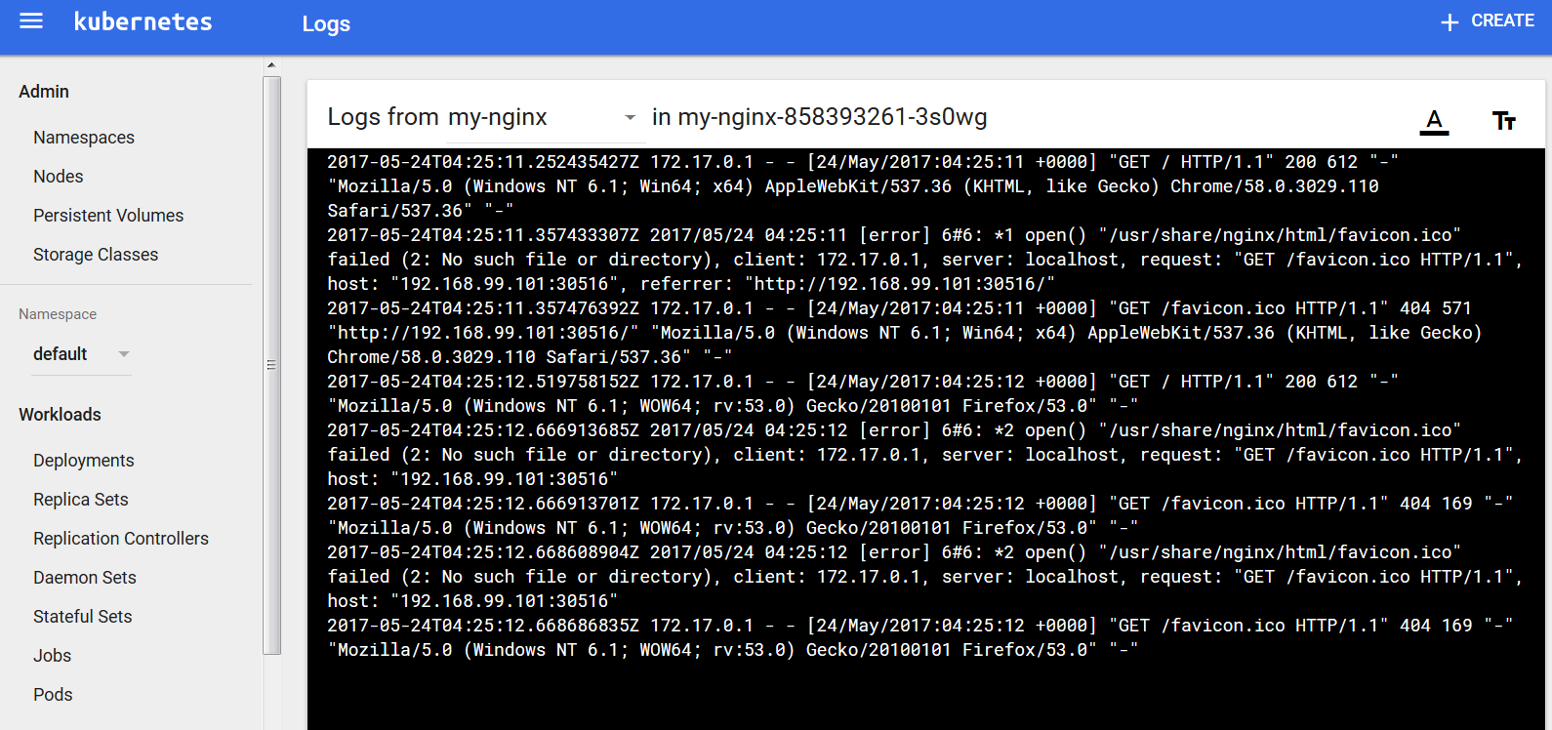

At this point, you can remove the Deployment, Service and Pods for nginx.

#### Tip

Note: if you have trouble creating, running or restarting minikube, it may help to clear the directory .minikube under the current user directory:

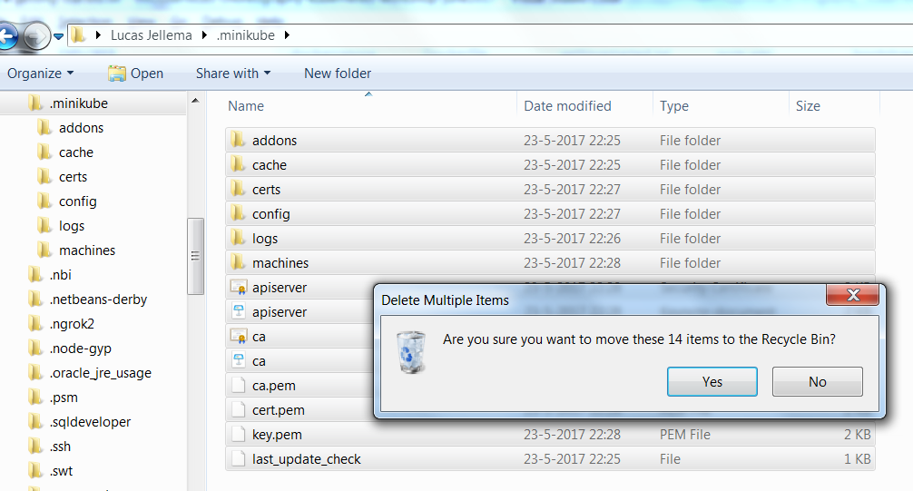

#### Tip 2 – No Internet Connection:

You need an internet connection to download Docker Container images. If none is available, we can load images directly from a tar ball into the Docker Server. The steps for this are:

* create a shared folder mapping from a local directory on your laptop into the minikube virtual machine (by configuring a shared folder in VirtualBox when minikube is down). Note: remove the existing, incorrect folder mapping for \\?\c\Users.  
  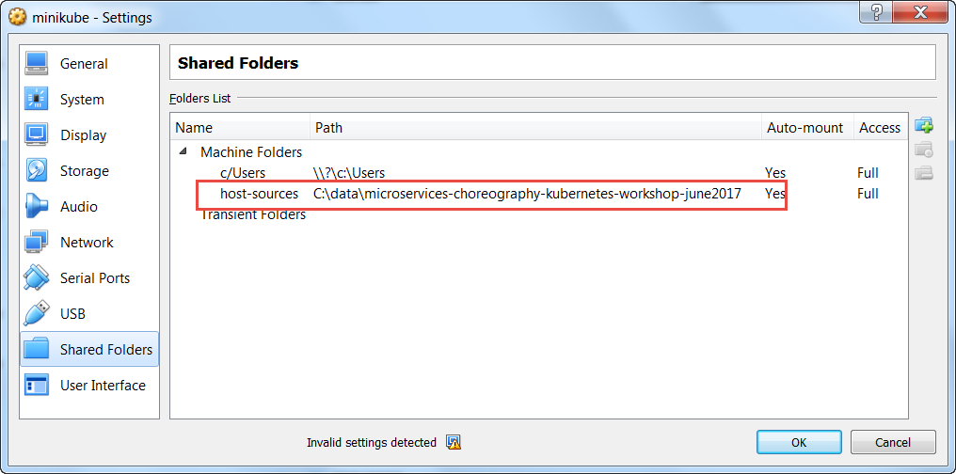
* copy tar balls for images to that local directory  
  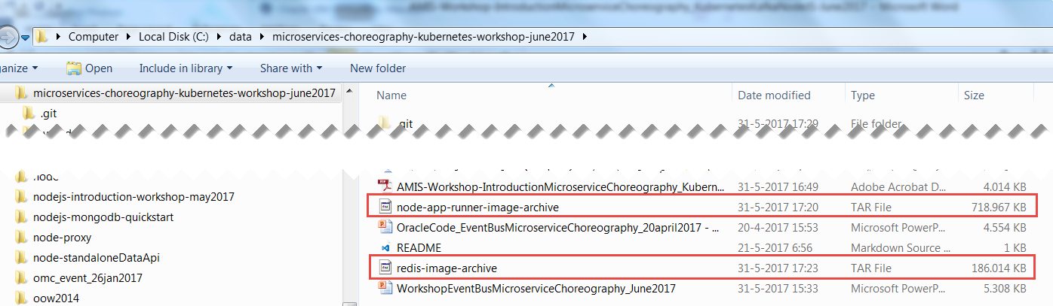
* start minikube
* retrieve ip address for minikube vm: minikube ip
* open an SSH session into minikube ; The IP address was retrieved above. The port to use is 22 and username is *docker*, password is *tcuser*.  
  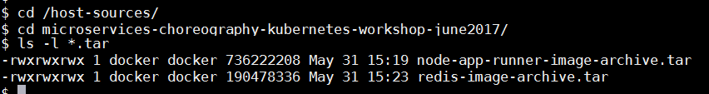
* load tar balls into docker using docker load --input <tar ball>  
    
  docker load --input node-app-runner-image-archive.tar  
  docker load --input redis-image-archive.tar  
  docker load --input nginx-image-archive.tar  
    
  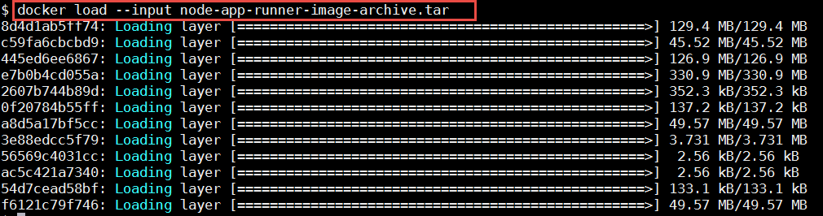  
    
  show the images:  
  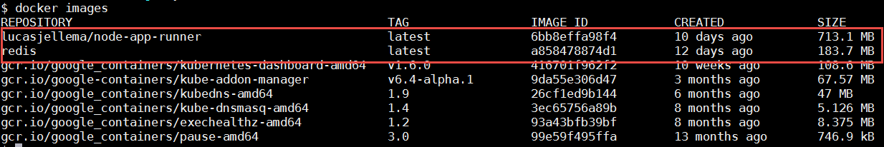
* at this point, Pods based on these images can be started, even when no internet connection is available

# 2. Run your first Microservice

In this section, we will run a simple microservice. First as stand-alone Docker container, then in a Pod on the Kubernetes cluster. The microservice is implemented by a Node.js application – requestCounter – that accepts HTTP requests, counts request and returns the current count as the HTTP response.

## Run RequestCounter in Docker

If you are using Docker Tools, then run the Docker Quickstart Terminal. On the command line in Docker Quickstart Terminal, run this command:

docker-machine ip default

It will return the IP address on your laptop assigned to the Docker VM that will run the Docker containers.



On Docker command line – either in Linux server with Docker installed or in Docker Quickstart Terminal – run a container with the requestCounter.js Node.JS application:

docker run -e "GIT_URL=https://github.com/lucasjellema/microservices-choreography-kubernetes-workshop-june2017" -e "APP_PORT=8080" -p 8005:8080 -e "APP_HOME=part1" -e "APP_STARTUP=requestCounter-2.js" lucasjellema/node-app-runner

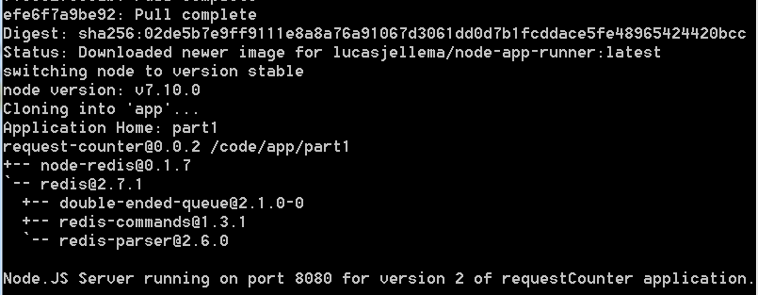

When the microservice is running, it can be accessed on your laptop in the browser, at the IP address returned by docker-machine ip default and at port 8005 – the host port mapped to the container port 8080 in the docker run startup command.

http://192.168.99.100:8005

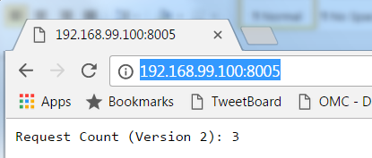

Execute the Docker run command again, with a small twist: change 8005 to 8006:

docker run -e "GIT_URL=https://github.com/lucasjellema/microservices-choreography-kubernetes-workshop-june2017" -e "APP_PORT=8080" -p **8006**:8080 -e "APP_HOME=part1" -e "APP_STARTUP=requestCounter-2.js" lucasjellema/node-app-runner

A second container will be started for you, running the same application, listening at the same port – inside the container – and mapped to a different port at the host:

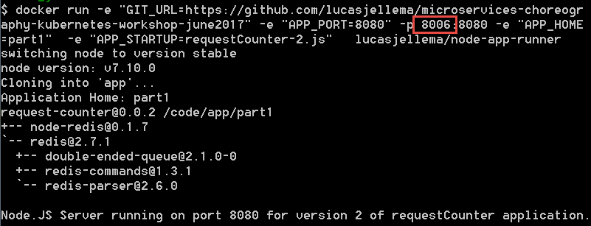

http://192.168.99.100:8006

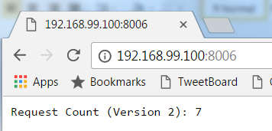

Use docker ps to check on the two containers currently running:

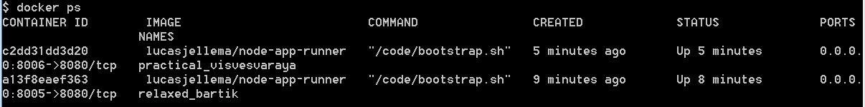

Stop these containers using

docker stop <first three characters of container id>

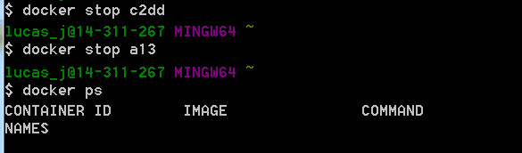

Then use docker run to start a fresh container :

docker run -e "GIT_URL=https://github.com/lucasjellema/microservices-choreography-kubernetes-workshop-june2017" -e "APP_PORT=8080" -p 8005:8080 -e "APP_HOME=part1" -e "APP_STARTUP=requestCounter-2.js" lucasjellema/node-app-runner

Access the microservice offered by this container once more.

http://192.168.99.100:8005

Verify the value returned by the request counter. Is it in line with the total number of calls you have made to the service?

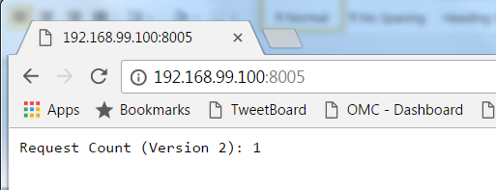

## Run and Expose the microservice on Kubernetes

Docker can run individual containers just fine. However, creating microservices that may consist of multiple containers, that may interact with other containers and that may need to scale and restarted upon failure is not easy with only Docker. Enter Kubernetes, a container management platform.

Let’s run one instance of one standalone microservice on Kubernetes – basically the same thing as running a single Docker Container:

From workshop directory part1/kubernetes, run

kubectl create -f pod.yaml



This will create a Pod according to the specification in the file pod.yaml. Open this file and review the specification for the Pod. Crucial elements are the name of the Pod, the name of the underlying Docker Container Image and the values of the environment variables to be passed into the container.

Check on the Pod in the Dashboard (note: it will take up to a few minutes to get running for the first time because of the downloading of container images):

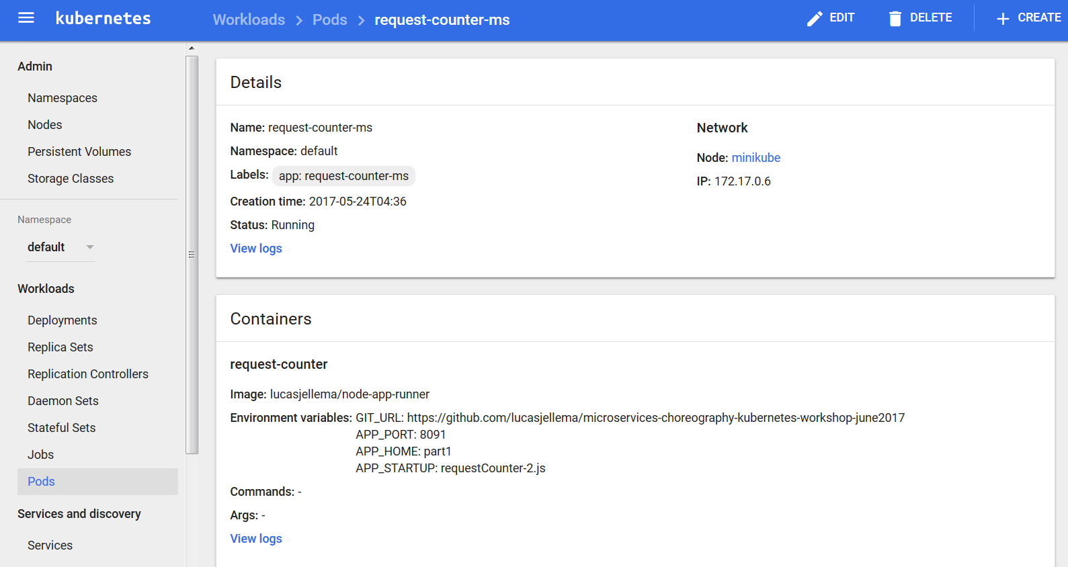

and verify the logging:

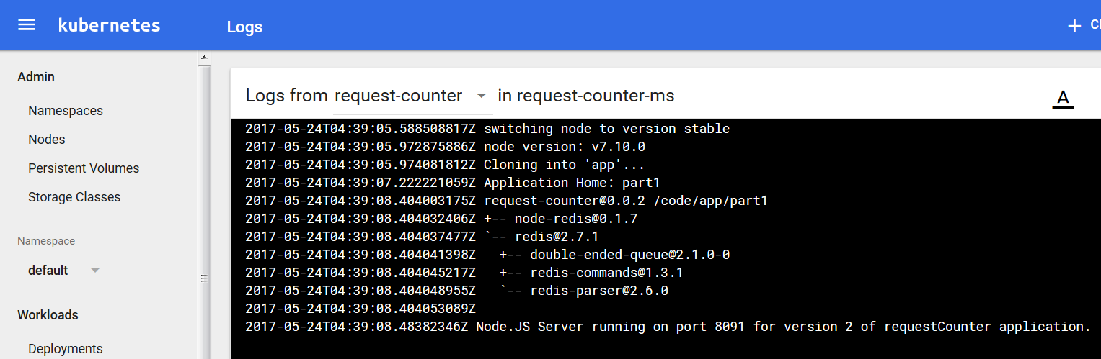

Expose the Pod using a Service to consumers outside the cluster:

kubectl.exe expose pod request-counter-ms --type=NodePort



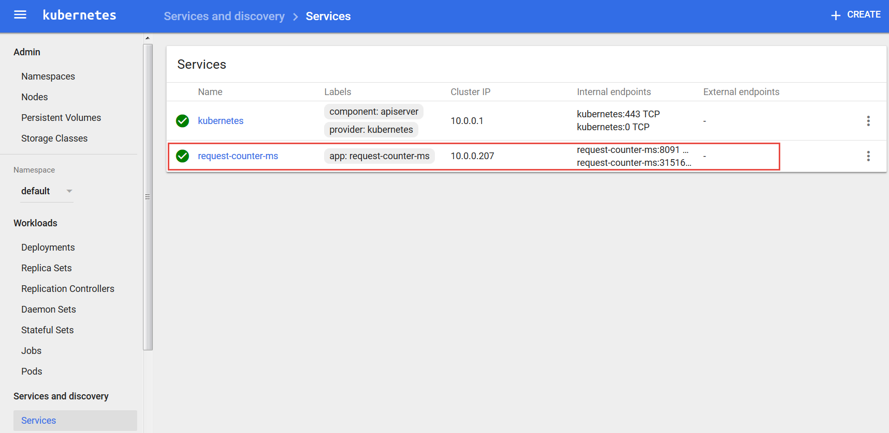

Using kubectl get services to inspect the service:



Also to get the url for accessing the service created for pod request-counter-ms:

minikube.exe service --url=true request-counter-ms



Access the microservice at the URL retrieved (cluster ip: <port exposed for pod>):

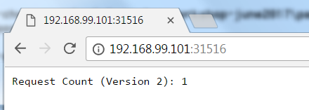

Refresh the browser a few times. See how the counter value increases.

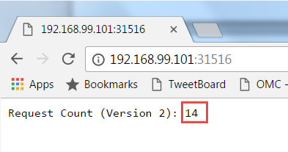

Delete all Pods and Services you have created on Kubernetes:

kubectl delete po,svc --all

## Handle Scaling Up and Down

We will look at deployments on Kubernetes - you can run an application by creating a Kubernetes Deployment object, and you can describe a Deployment in a YAML file. Through Deployments, multiple replicas of a Pod can be started and managed by Kubernetes. These instances can be exposed under a single external IP, with Kubernetes taking care of routing incoming traffic to one of the Pods.

Let’s run the request counter microservice again, through a deployment object – as described by file deployment.yaml.

kubectl create -f deployment.yaml



Display information about the Deployment:

kubectl describe deployment request-counter-ms-deployment

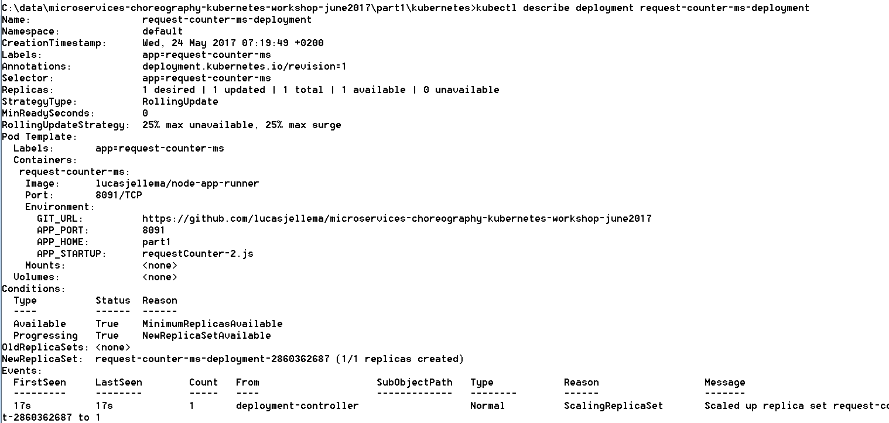

You can also check in the Dashboard for the Deployment, the Pods created as part of it and the Replica Set:

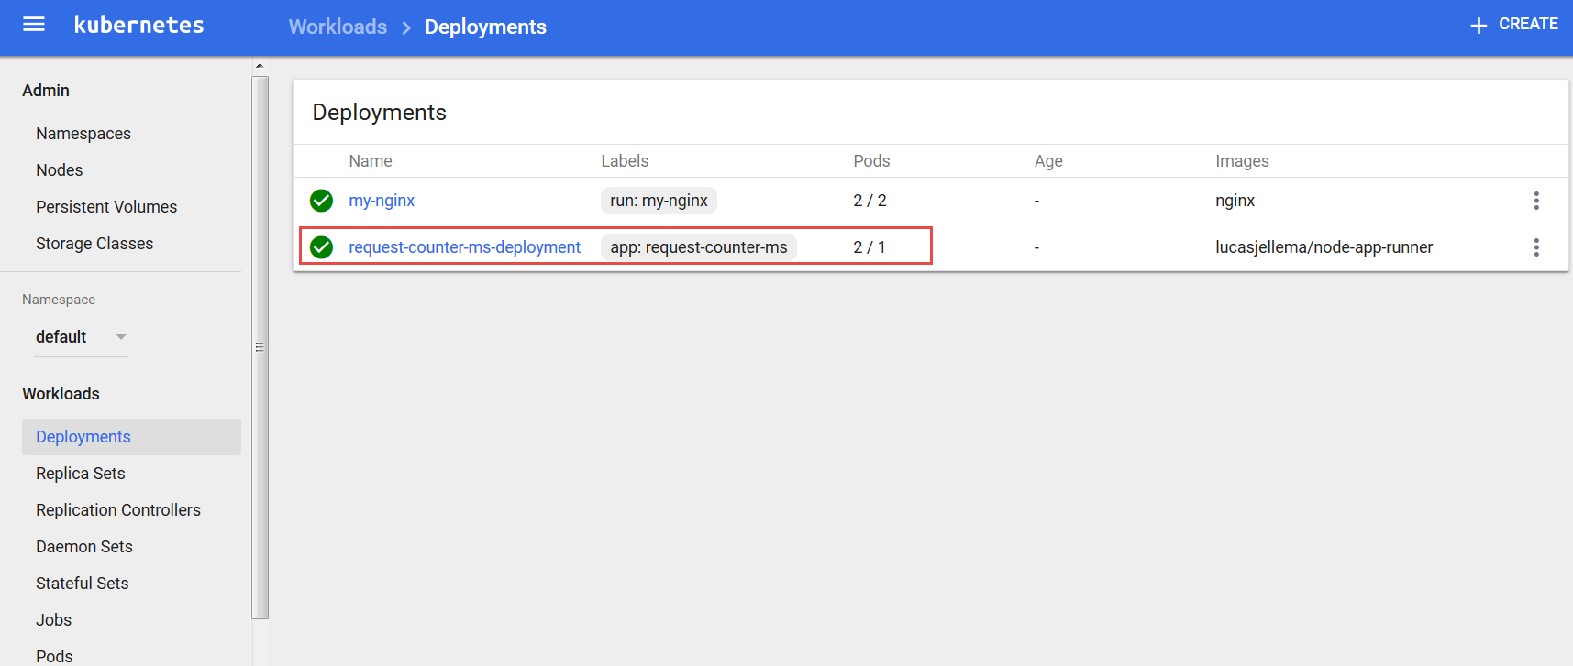

Instead of exposing a single Pod through a Service we can also expose the Deployment. Do so now, using:

kubectl expose deployment request-counter-ms-deployment --type=NodePort



With kubectl get services:



Access the microservice in the browser at the specified port (30553 in this case) or simply using:

minikube.exe service request-counter-ms-deployment

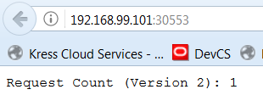

Hit the url a few more times, increasing the counter as you go.

Now we will scale up the number of replicas – i.e. the number of container instances that is running on the cluster. This can be done by editing the deployment.yaml file and using kubectl apply -f deployment.yaml – or through the Dashboard:

Click on the node Deployments in the navigator. Open the drop down menu for the deployment request-counter-ms-deployment and click on *View/edit YAML*.

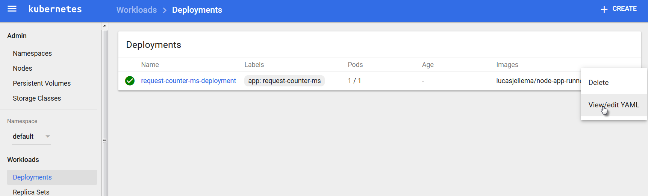

Change the value of the attribute replicas from 1 to 2:

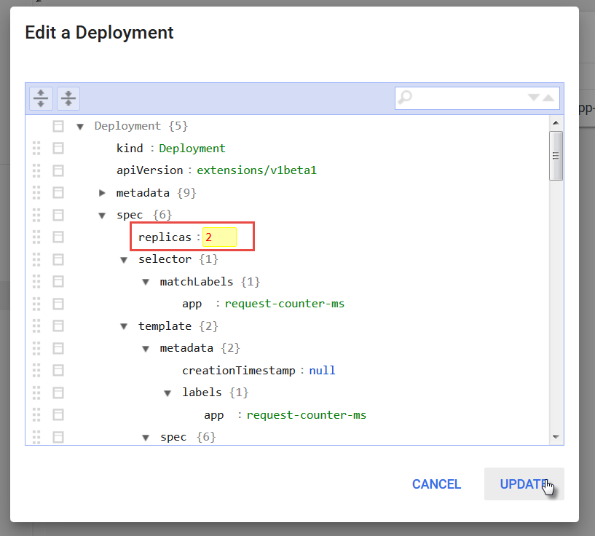

and click on Update.

You will see that the deployment has now 2 pods. The change is pending – as indicated by the icon on the left hand side.

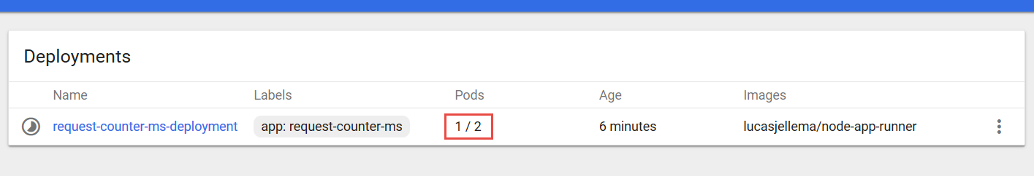

After a little while, two pods are running:

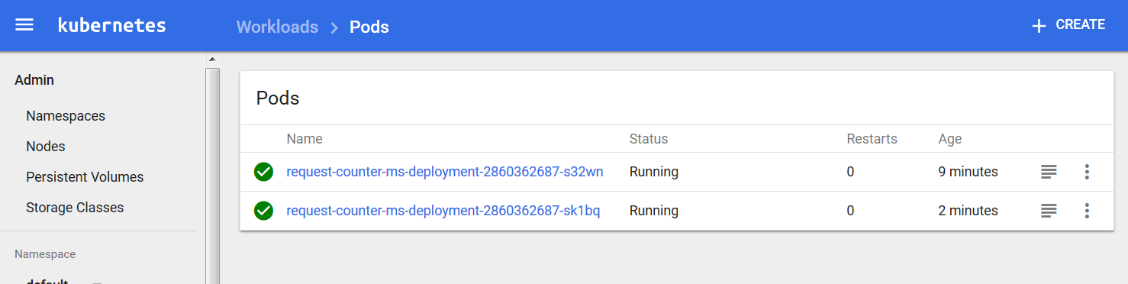

You can access the microservice again from the browser, or you can do so using curl from the command line:

curl http://<ip of cluster>:<port exposed by service>

Your results will be similar to the following:

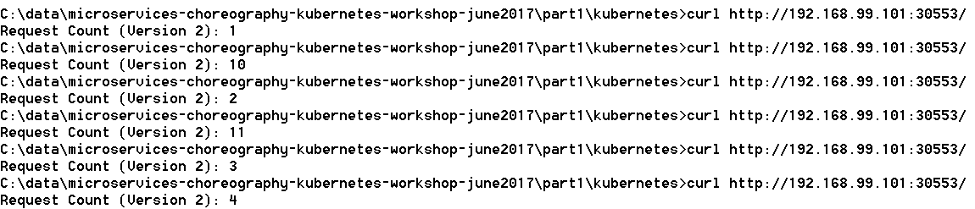

Instead of a smoothly increasing counter value, we see values that are not part of the same sequence and we even get duplicate values. If you look at the code of /part1/requestCounter-2.js – the application running in the pods – it is not hard to spot the flaw: these applications are not stateless and therefore do not support horizontal scaling.

Note how Kubernetes takes care of load balancing for us. We access a endpoint exposed from the cluster, and traffic is distributed over the available Pods.

Delete one of the pods, for example in the Dashboard:

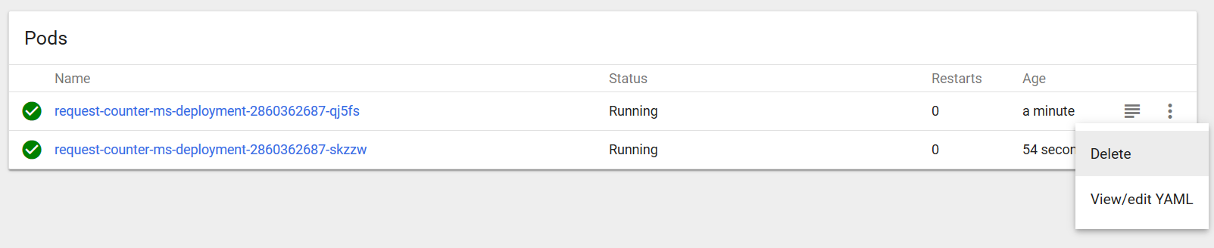

You will see a new Pod being created immediately. In the deployment definition we stated two replicas are required – and that is what Kubernetes ensures.

Now once more access the microservice a few times, for example using curl:

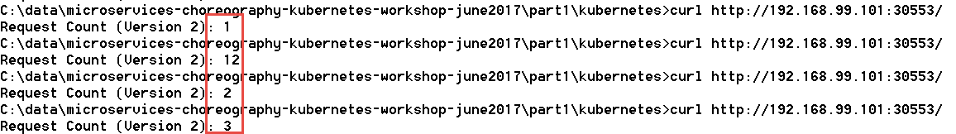

The value 1 is obviously returned by the newly instantiated Pod.

## Adding a Cache to the Microservices Platform and running a Stateless version of RequestCounter

Add a second pod with Redis in it

kubectl run redis-cache --image**=**redis --port**=**6379



Expose redis within cluster:

kubectl expose deployment redis-cache --type=ClusterIP



From the command line we can inspect the services exposed on our minikube cluster:

kubectl get services

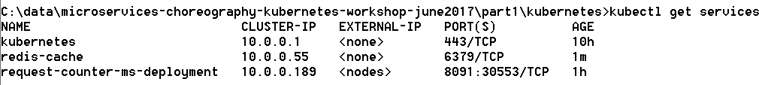

This time, since redis-cache is exposed only inside the cluster, this command:

minikube.exe service redis-cache

produces no output.

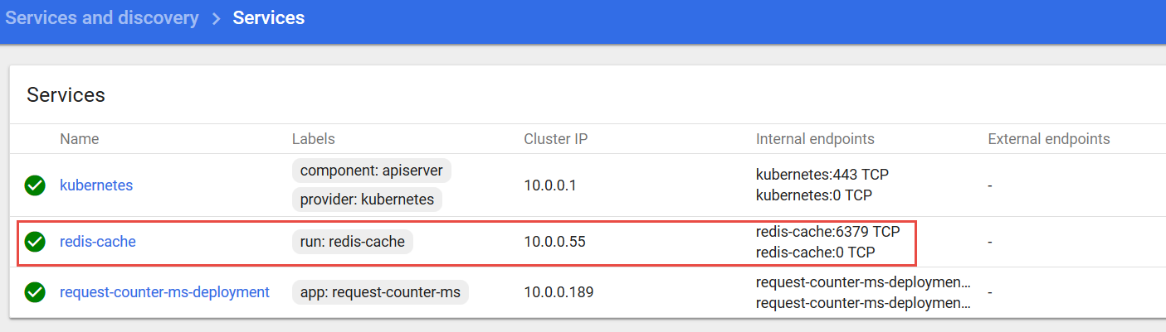

The hostname for the Redis cache service inside the cluster is redis-cache and the port is 6379 – at this endpoint, other pods in the cluster can access the service.

Upgrade deployment RequestCounter to version with Redis backing. V3: no lock, v4: optimistic lock

kubectl apply -f deployment-v2.yaml --record



Check on the status of the rollout of the change:

kubectl rollout status deployment request-counter-ms-deployment



We can inspect the history of a specific deployment and see which changes have been applied to it:

kubectl rollout history deployment request-counter-ms-deployment



In the dashboard, if we are quick we can see the pods being restarted. If we are not so fast, we can see both pods running (again) – having been restarted fairly recently:

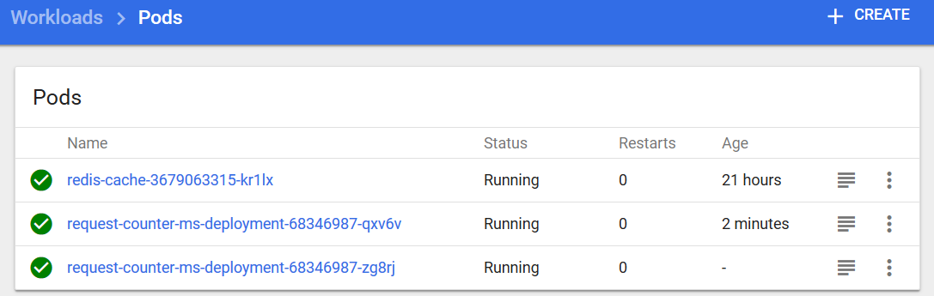

Both Pods are running again, from the logs you can tell that both are running the new version of the application – powered by Redis.

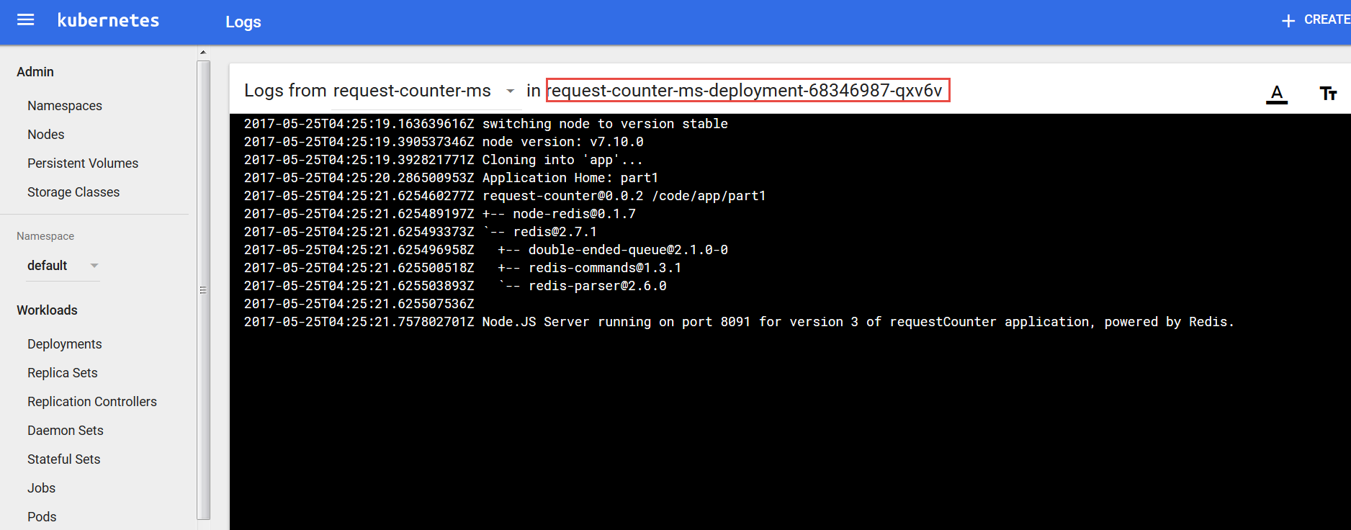

The situation we have now established is visualized below:

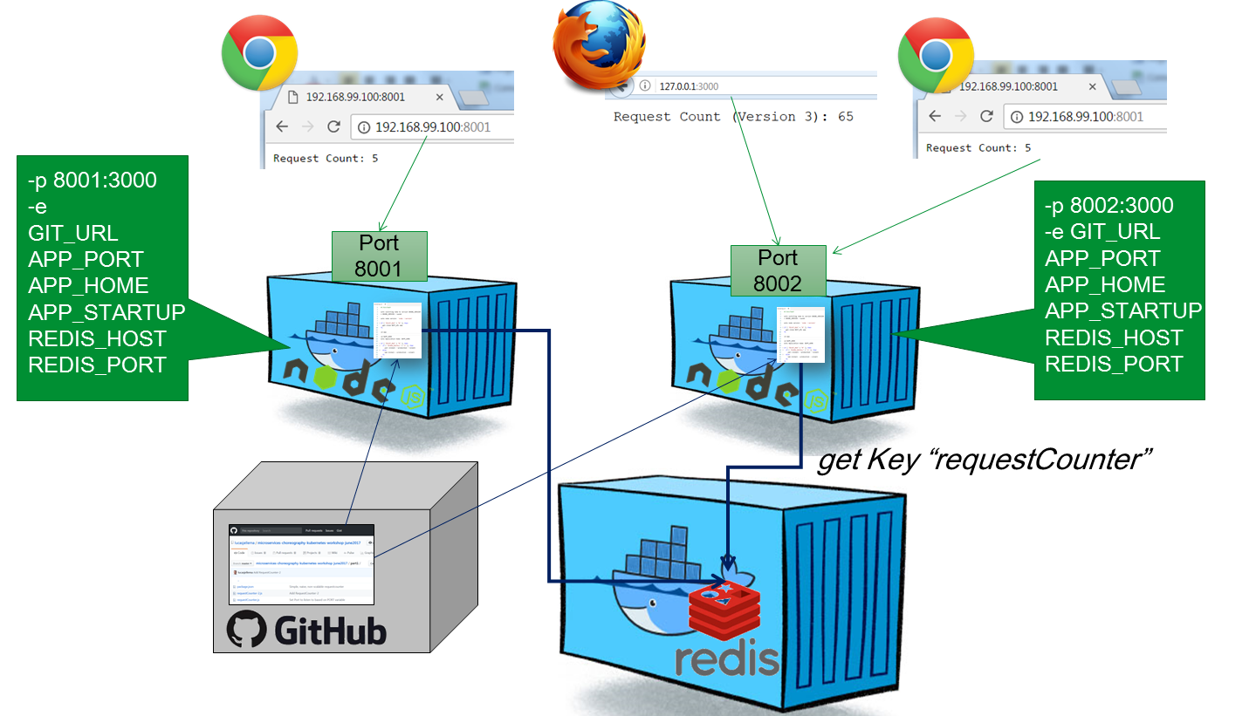

We can access the microservice (again) in the browser:

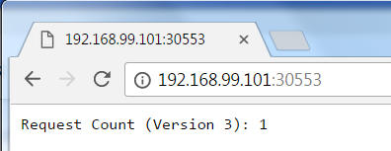

And from the command line we can do the curl thing a few times:

curl http://<ip of cluster>:<port exposed by service>

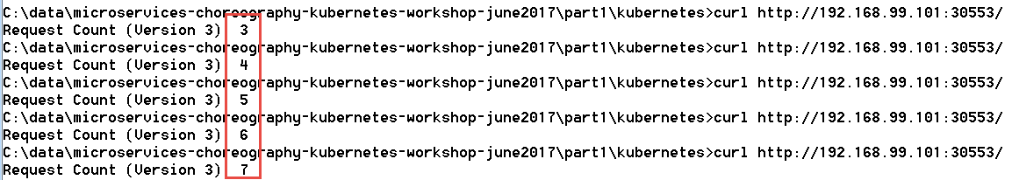

This time round, we do not get two counters incrementing in the background. Just a single incrementing value. And supposedly, that value is stored in the Redis cache where both instances access and manipulate it.

That should mean that we can stop and (re)start one or even both pods and then continue with the count as though nothing happened. Let’s try that out. Stop one of the pods (note: get the name of the Pod in your case from either the command line using *kubectl get pods* or through the dashboard)

kubectl delete pod request-counter-ms-deployment-68346987-qxv6v --grace-period=60



In the dashboard we can see how a new pod is started – because in the deployment we specified 2 replicas to always be running :

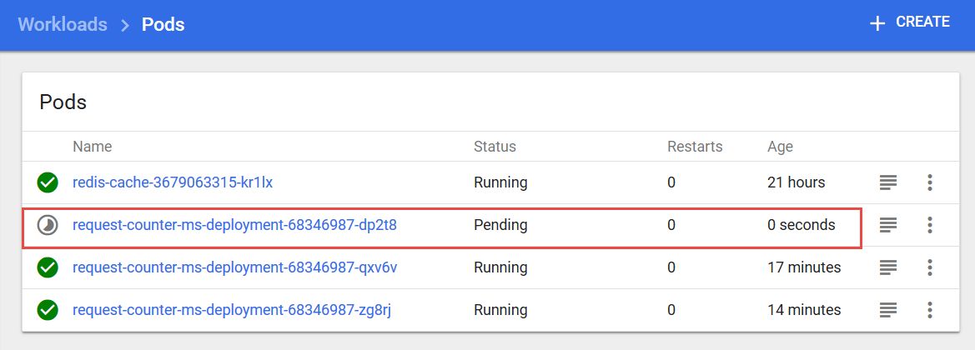

and a little bit later the Pod we asked to be deleted is gone:

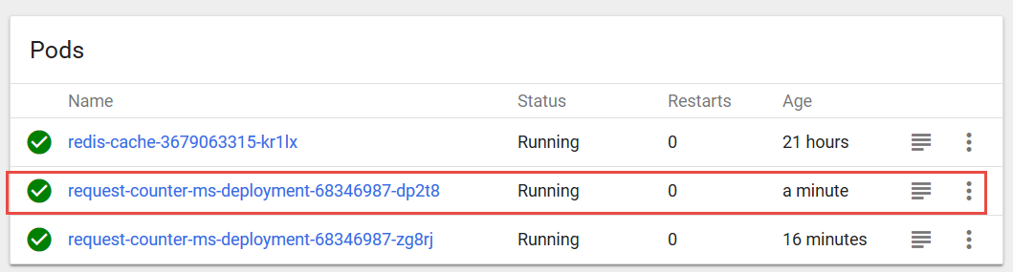

We can also delete our other pod, to be sure any state lingering in the original pods is gone:

kubectl delete pod request-counter-ms-deployment-68346987-zg8rj

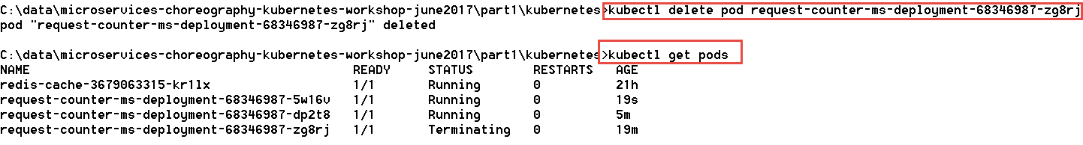

Again, we see a new pod running and the old instance being terminated. At this point, both original pods are gone. If we access the request counter microservice, we will find that the counting continues where it had left off:

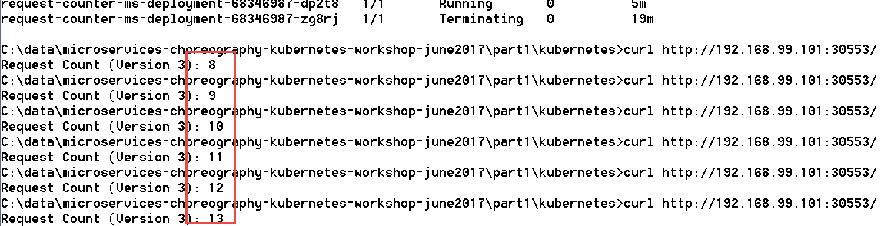

Of course now we have moved the burden of state to the Redis pod. If we restart that pod, we will get a reset in the counter value, because currently the cache is not persisted outside the container and its contents vanishes when the container dies. Note that we can have Redis be persisted to files outside container.

kubectl delete pod <name of redis-cache-… pod>

A new pod will be started after a few seconds and the old one terminated. When we then access the microservice requestcounter, the inevitable has happened: a counter reset. The old value was lost when the Redis cache pod was terminated:

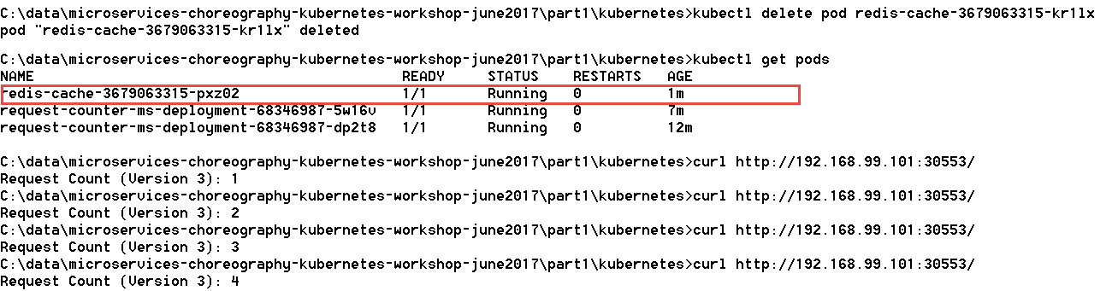

### Resources

See: <https://kubernetes.io/docs/concepts/services-networking/service/#publishing-services---service-types> on services in Kubernetes

Port forwarding from host to Redis Pod: <https://kubernetes.io/docs/tasks/access-application-cluster/port-forward-access-application-cluster/>

*Rolling updates* with K8s deployment: <https://tachingchen.com/blog/Kubernetes-Rolling-Update-with-Deployment/>

Graceful shutdown of pods: <https://pracucci.com/graceful-shutdown-of-kubernetes-pods.html>

### Useful Kubectl commands

To see the logs from a specific pod:

kubectl logs my-pod

To open a shell in the running container in a pod with only one container (see: <https://kubernetes.io/docs/tasks/debug-application-cluster/get-shell-running-container/>) :

kubectl exec –it my-pod -- bash



Type exit in the shell to return.

Run a command in the container in a Pod:

kubectl exec my-pod command



To open a shell in a running container in a pod with multiple containers:

kubectl exec –it my-pod -c my-container -- bash

See the API reference for Kubectl exec for more details: <https://kubernetes.io/docs/user-guide/kubectl/v1.6/#exec>

An SSH connection can be created into the VM running the minikube cluster:

Username is Docker, password is tcuser.



Check for example all running containers with: docker ps

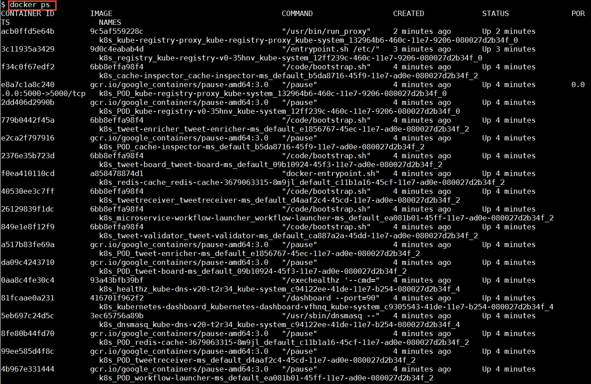

Save images from local docker server to archive:

docker save -o /home/images-archive.tar image1 image2 lucasjellema/node-appp-runner

docker save -o /home-sources/images-archive.tar redis lucasjellema/node-app-runner

# 3. Introducing the Event Bus Microservice into the Microservices Platform

Microservice orchestration through an event bus is one of the ultimate goals of this workshop. Let’s add an event bus to our microservice platform – using Apache Kafka.

Note: there are many articles and resources for running Kafka & Zookeeper in in Docker and in Kubernetes. Some resources are listed below. Unfortunately, none of these options really worked well for me. In the time I had available for preparation, I could not get a reproducible case to work as desired.

Therefore, you will work with a lean Virtual Machine that runs in VirtualBox.

A very interesting alternative is to work with Kafka in the Cloud. Various providers offer a Kafka PaaS service – for example IBM BlueMix and Oracle Event Hub. An interesting option is CloudKarafka which offers a free tier and which is very easy to get going with. See <https://www.cloudkarafka.com/plans.html> for details - and the free Developer Duck Plan.

## Getting started with the Kafka VM

Running the VM requires 2Gb of RAM and approximately 7Gb of free HD space

Start VirtualBox

Import the VM image – KafkaWorkshop.ova - by going to File, Import Virtual Appliance and browse to the image file. The VM requires 2Gb of RAM to run.

### Configure Networking in VM

To access the Kafka instance running inside the VM from your laptop, you need to ensure that you enable network access to the VM. The instructions in this article (AMIS Technology Blog: <https://technology.amis.nl/2017/01/29/network-access-to-ubuntu-virtual-box-vm-from-host-laptop/> ) show what you have to configure in order to be able to access the VM on its own IP address.

After arranging access to the VM, you may want to define a logical host name for the Virtual Machine – by adding an entry to the hosts file: C:\Windows\System32\drivers\etc\hosts, as shows below:

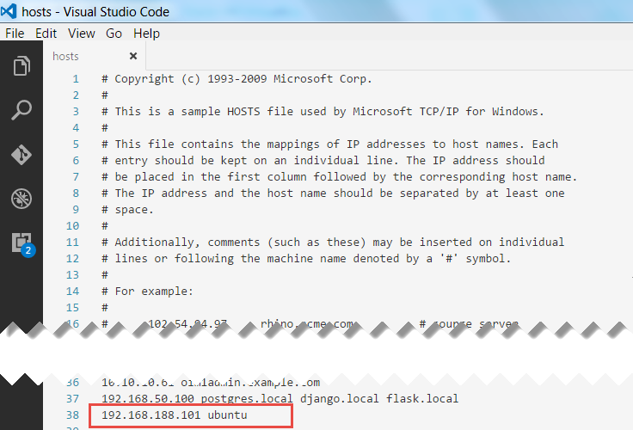

Note: *ubuntu* is the (advertised) host name of the Kafka in the VM; to play nice with Zookeeper it seems convenient to use that same name as the host name in our hosts file.

### Start the VM

The VM will boot to a graphical login screen

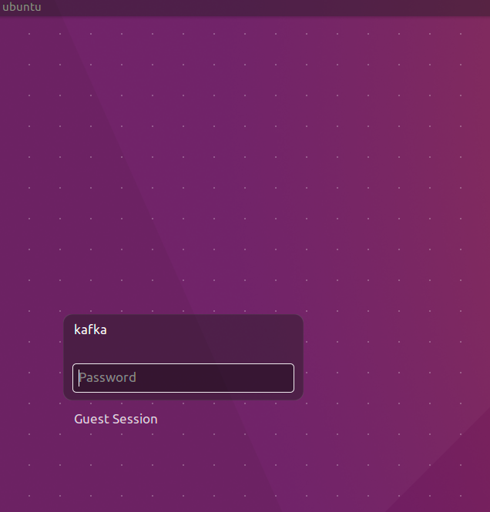

The VM has two users: *root* and *kafka*. Both have password Welcome01.

The VM contains:

* Ubuntu 16.04 LTS
* Oracle JDK 8
* Eclipse Neon.2
* Node 7.4
* Zookeeper
* Firefox
* Chrome
* Postman
* confluent-platform-oss-2.11
* kafka-manager 1.3.2.1. When started runs on <http://localhost:9000>
* kafkatool 1.0.1

## Getting to know the Kafka VM

Login to the VM: kafka/Welcome01

Start Terminator from the Unity menu

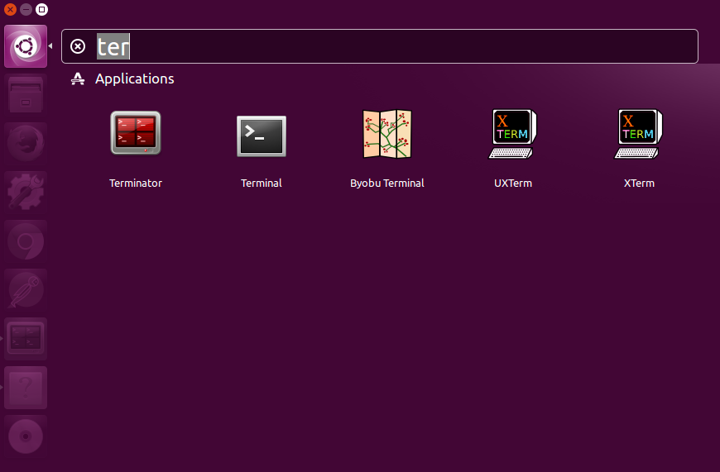

Split the screen horizontally – as shown in the next figure - and both screens vertically by right clicking in the window.

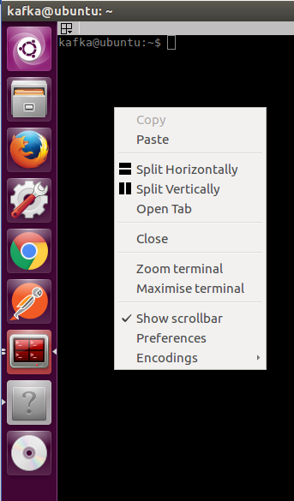

You will end up with four terminal windows.

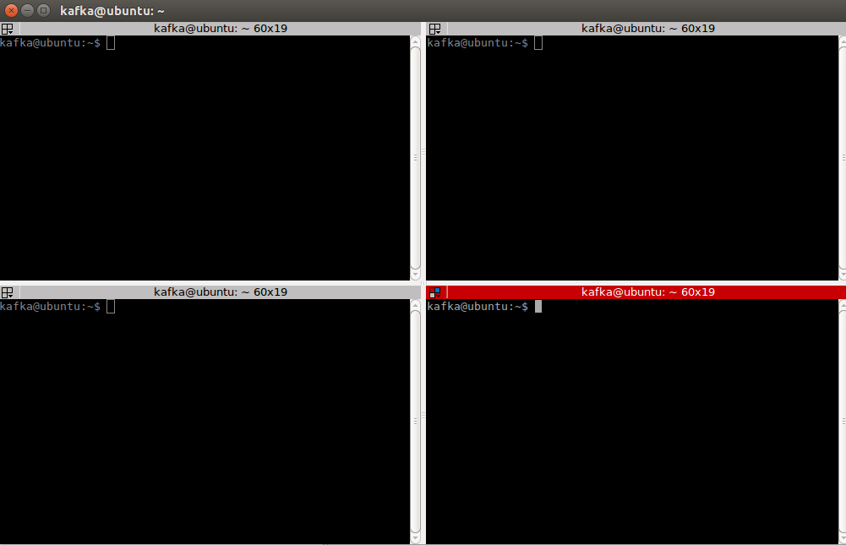

In the first terminal window start a Kafka broker:

kafka-server-start /etc/kafka/server.properties

Start in the second terminal window start the kafka manager:

kafka-manager

Start kafkatool in the third terminal window:

kafkatool

Minimize the tool. You will use it at a later time.

Continue in the fourth terminal window

### Create a topic

Create a topic:

kafka-topics --create --zookeeper localhost:2181 --replication-factor 1 --partitions 1 --topic test

Confirm the topic is created:

kafka-topics --list --zookeeper localhost:2181

Open kafkatool and confirm the topic is created

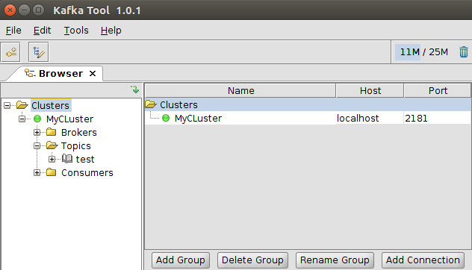

### Produce a message

Focus on the fourth terminal window again and type:

kafka-console-producer --broker-list localhost:9092 --topic test

Press enter. No feedback appears; the cursor sits blinking and waiting for your input.

Type a message and press enter:

Hello World!

Check the message is created using kafka-manager and kafkatool.

Open kafkatool. Indicate the messages on the topic are string. Click the update button. Click the refresh button to view how many messages are present on the topic. Confirm the number is 1.

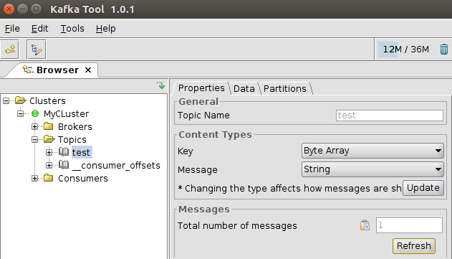

Open the partition under the test topic. Click the green play button. Confirm the Hello World! message has arrived.

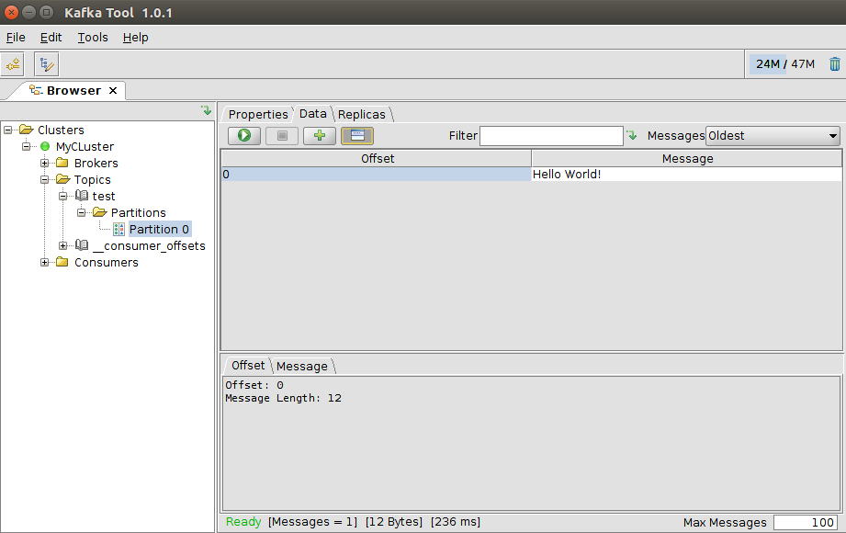

### Consume a message

Consume a message

kafka-console-consumer --bootstrap-server localhost:9092 --topic test --from-beginning



Confirm that the previously posted message has been consumed.

## Run a Microservice with Kafka Interaction

In one of the terminal windows in your Kafka VM – determine the IP address that is assigned to the VM:

ifconfig

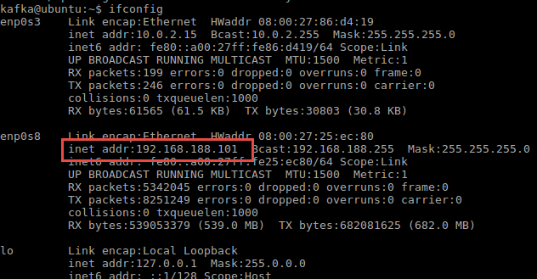

This is the address for the Kafka Host that we can use in applications that interact with Kafka. Take note of this IP address.

Create a new Kafka Topic called event-bus:

kafka-topics --create --zookeeper localhost:2181 --replication-factor 1 --partitions 1 --topic event-bus

Confirm the topic is created:

kafka-topics --list --zookeeper localhost:2181

Run a Pod on Kubernetes that starts a Node.JS application that listens to the Event Bus topic on the Kafka Broker. You do this using the EventBusListener.yaml file in directory part3/event-bus-listener. Before you run the yaml file, check out its contents. Take note of the ports, the environment variables such as KAFKA_TOPIC (set to event-bus) and KAFKA_HOST. The *lifecycle* element in the yaml file ensures that the Kafka Host (the VM running the Kafka Broker) is known as a host inside the EventBusListener container. Ensure that the IP address used in the command executed is the correct one – that is: the IP address returned inside the Kafka Host using ifconfig.  
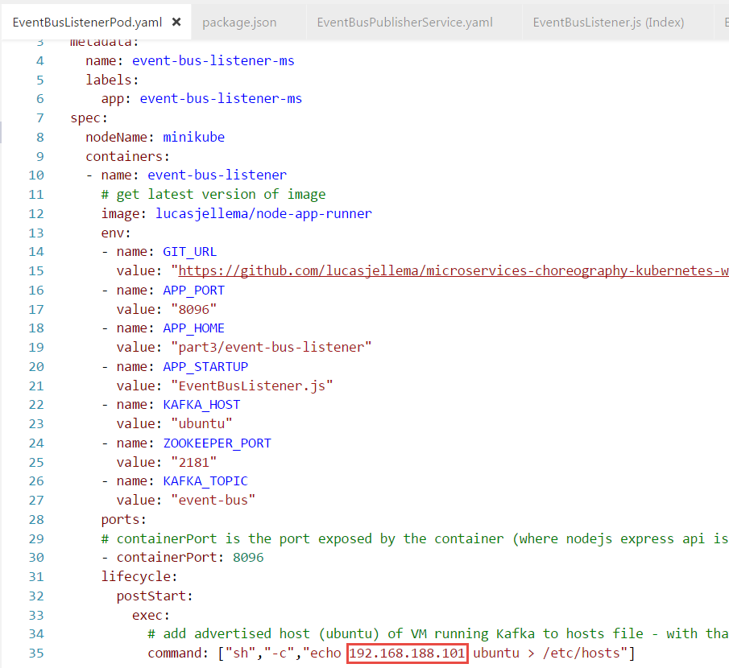

When the yaml file is correct, then run:

kubectl create -f EventBusListenerPod.yaml -f EventBusListenerService.yaml

You can check in the Kubernetes Dashboard whether the Pod has started running successfully and is now listening to a Kafka Topic:

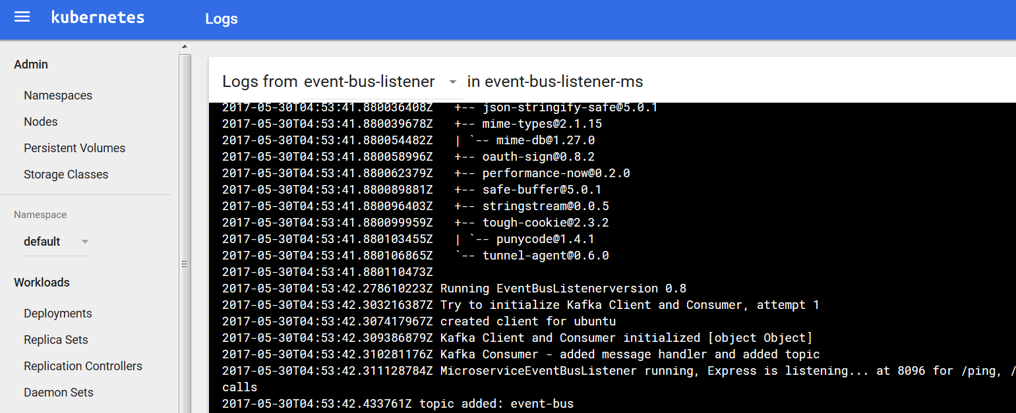

Then, publish an event to topic event-bus from the command line in the VM running the Kafka Broker:

kafka-console-producer --broker-list localhost:9092 --topic event-bus

Press enter. No feedback appears; the cursor sits blinking and waiting for your input. Type a valid JSON message, something like:

{"Wish" : "Hello To World"}



If you check the logs in the Kubernetes Dashboard, you should find that the event has been received:

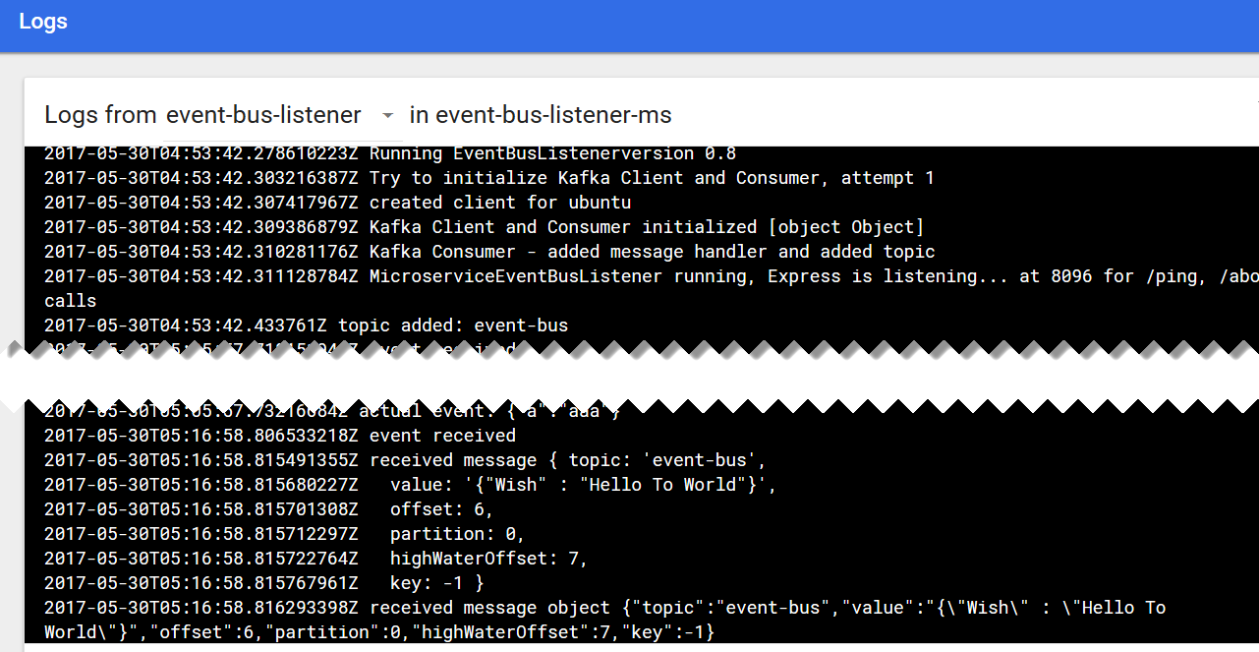

Using the port assigned to service



You can access the event bus listener microservice from the browser on your laptop (using the IP address of the Docker machine) and get a list of all events consumed thusfar from topic event-bus:

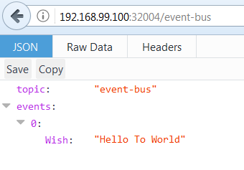

## Microservice on Kubernetes that Publishes Events

As a next step, we will run a microservice that takes input from you – the user – through simple HTTP requests and that turns each request into an event published on the event bus. The *event bus listener* microservice that we launched in the previous section will consume all those events and make them available through the browser. That means we realize communication between two microservices that are completely unaware of each other and only need to know about the common microservices platform event-bus capability.

Directory part3\event-bus-publisher contains the sources for this microservice.

kubectl create -f EventBusPublisherPod.yaml -f EventBusPublisherService.yaml

Check in Kubernetes Dashboard or through *kubernetes get pods* and *kubernetes get services* if the creation is complete – and what the port is that was assigned to the *EventBusPublisherService*.



With http requests from your browser - or using CURL or Postman – you can trigger the Event Bus Publisher microservice into publishing events to the Event Bus:

http://<Docker Machine IP>:<port assigned to Kubernetes service>/publish?area=greenland&importance=high&color=orange

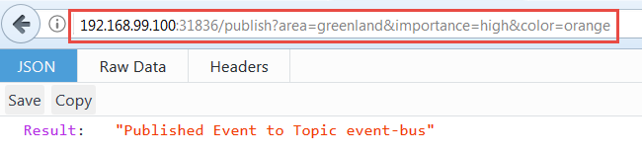

The Event Bus Listener microservice is still running. Through the browser – or by looking at the logs for the Pod - you can check if it has consumed the event that was just published through the Event Bus Publisher microservice.

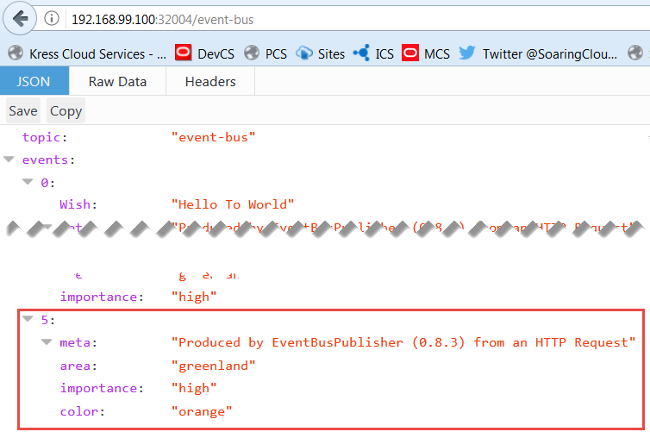

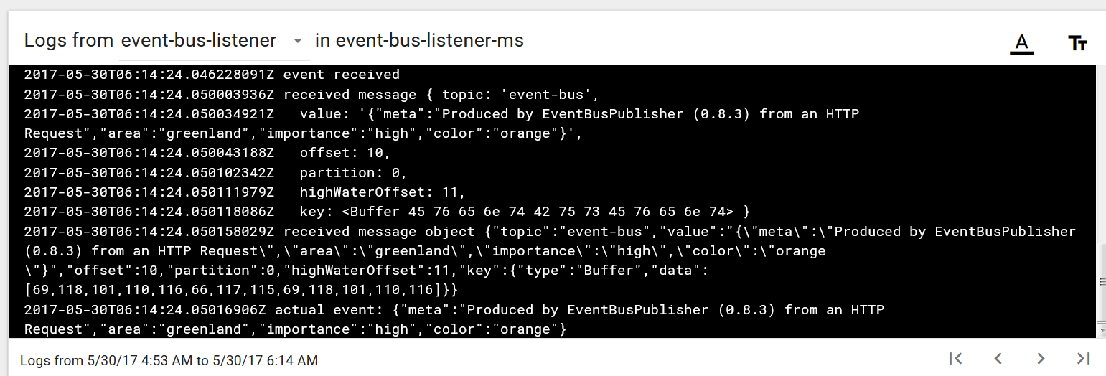

When the HTTP Request to the Event Bus Publisher results in a message returned from the Event Bus Listener microservice, then we have succeeded. Microservice interaction in a most decoupled way. Time for some choreography!

Note: At this point, you can stop and delete all components currently running on Kubernetes. A quick way to tear all components down is:

kubectl delete po,svc,rc --all

# 4. Microservice Choreography – on Kubernetes and Kafa

In this section, a multi-step workflow is implemented using various microservices that dance together – albeit unknowingly. The choreography is laid down in a workflow prescription that each microservices knows how to participate in.

Note: directory part4 contains a Postman Collection: MicroServiceTestSet.postman_collection with a few simple test calls for the microservices that we run in this section.

## Prepare Kafka Event Bus

The Kafka Event Bus was introduced in the previous section, using a Virtual Machine running on Virtual Box. We assume that this VM is (still) running. In this running VM, create two new topics (in a terminal window inside the VM):

kafka-topics --create --zookeeper localhost:2181 --replication-factor 1 --partitions 1 --topic workflowEvents

kafka-topics --create --zookeeper localhost:2181 --replication-factor 1 --partitions 1 --topic logTopic

The workflow choreography takes place through events published to and consumed from the first topic. Logging will be published to the second topic.

## Startup Cache Capability

In addition to the Kafka Event Bus, our microservices platform also provides a cache facility to the microservices. This cache facility is provided through Redis, by executing these commands:

kubectl run redis-cache --image**=**redis --port**=**6379

kubectl expose deployment redis-cache --type=NodePort

With these commands, a deployment is created on the Kubernetes Cluster with a pod based on Docker Image *redis* and exposing port 6379. This deployment is subsequently exposed as a service, available for other microservices on the same cluster and for consumers outside the cluster, so we can check on the contents of the cache if we want to. Type ClusterIP instead of NodePort is enough to allow access to other microservices (pods) on the cluster.

## Run Microservice TweetReceiver

The microservice TweetReceiver exposes an API that expects HTTP Post Requests with the contents of a Tweet message. It will publish a workflow event to the Kafka Topic to report the tweet to the microservices cosmos to take care of.

In directory part4/TweetReceiver, run:

kubectl create -f TweetReceiverPod.yaml -f TweetReceiverService.yaml

With this command, a new Pod is launched that listens for HTTP Requests that report a Tweet. This can be done through a recipe from IFTTT or with a simple call from any HTTP client such as Postman.

Using *kubectl get services* you can inspect the service that is created and the port at which it is exposed.

## Run Microservice Workflow Launcher

The Workflow Launcher listens to the Kafka Topic for events of type NewTweetEvent. Whenever it consumes one of those, it will compose a workflow event with a workflow choreography definition for that specific tweet. The data associated with the workflow is stored in the cache and thus made available to other microservices.

Run the Workflow Launcher with:

kubectl create -f WorkflowLauncherPod.yaml

Note: ensure that the KAFKA_HOST, ZOOKEEPER_PORT and REDIS_HOST and REDIS_PORT are correct in the yaml file.

This microservices does not expose an external service – all it does is listen to events on the Kafka Topic

When the microservice is running, it will listen for NewTweetEvents published by the TweetReceiver. If you check out the logs for WorkflowLauncher, you should find that any request send to TweetReceiver will now lead to activity in the WorkflowLauncher.

## Run Microservice ValidateTweet

The next microservice takes care of validating tweets. It can do so based on workflow events or in response to direct HTTP reqequests.

Run the microservice in directory part4/ValidateTweet.

kubectl create -f ValidateTweetPod.yaml

Also to expose an API for this microservice:

kubectl create -f ValidateTweetService.yaml

Using *kubectl get services* you can find out the port at which you can reach this microservice from your laptop. Using a simple curl, you can verify whether the microservices is running:

curl http://192.168.99.100:31139/about



You can try out the functionality of this microservice with a simple POST request to the url:  
http:// 192.168.99.100:31139/tweet:  
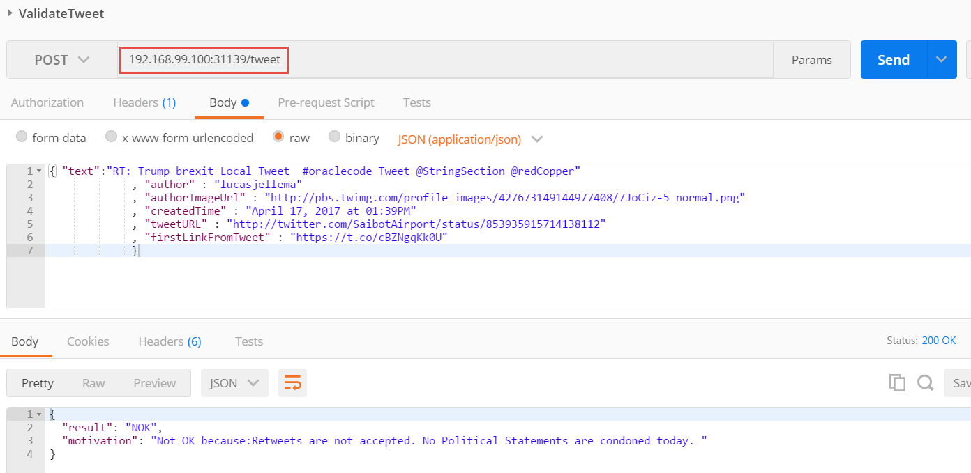

## Run Microservice to Enrich Tweet

This microservice takes the tweet and enriches it with information about the author, any acronyms and abbreviations, related tweets and many more details. Well, that was the intent. And could still happen. But for now all the enrichment that takes place is very limited indeed. Sorry about that. However, this microservice will play its designated role in the workflow execution, according to the choreography suggested by the workflow launcher.

Run the microservice from directory part4/ TweetEnricher:

kubectl create -f TweetEnricherPod.yaml

Also to expose an API for this microservice:

kubectl create -f TweetEnricherService.yaml

Using *kubectl get services* you can find out the port at which you can reach this microservice from your laptop. Using a simple curl, you can verify whether the microservices is running:

curl http://192.168.99.100:30649/about

You can try out the functionality of this microservice with a simple POST request to the url:  
http:// 192.168.99.100:31139/tweet:  
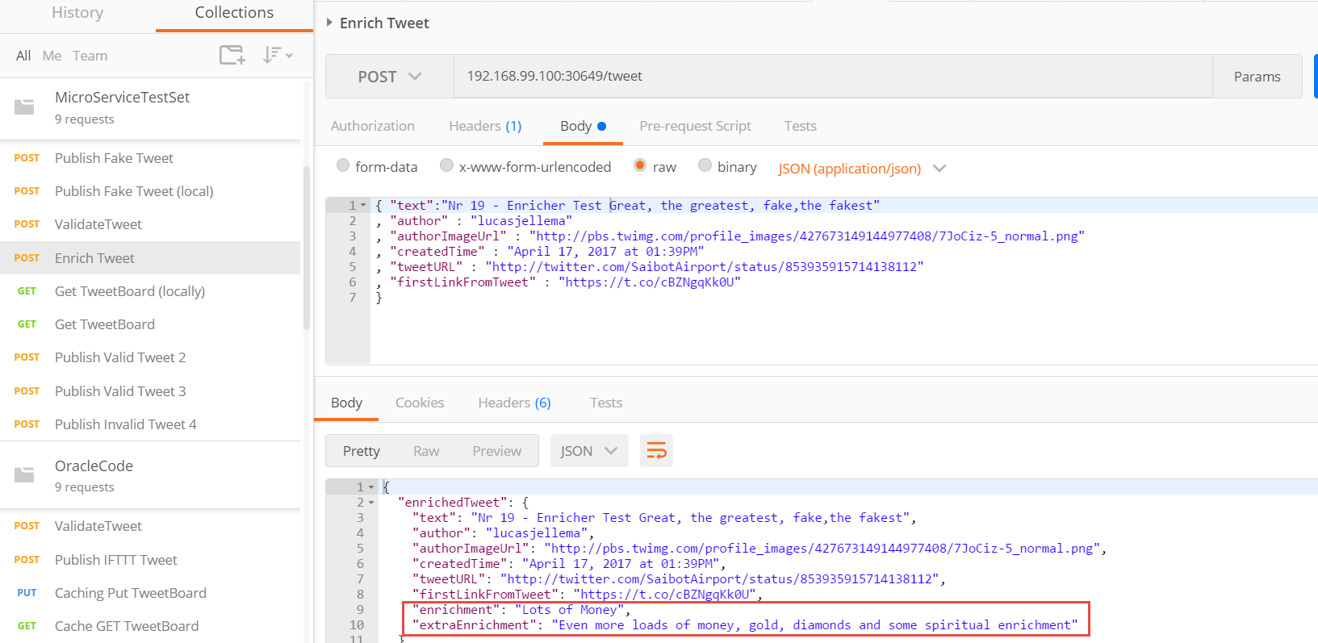

## Run Microservice TweetBoard

The last microservice we discuss does two things:

1. it responds to events in the workflow topic of type TweetBoardCapture (by adding an entry for the tweet in the workflow document) and
2. it responds to HTTP Requests for the current tweet board [contents] by returning a JSON document with the most recent (maximum 25) Tweets that were processed by the workflow

This microservice is stateless. It uses the cache in the microservices platform to manage a document with the most recent tweets.

Run a Pod on Kubernetes with this microservice using this command in directory part4/TweetBoard:

kubectl create -f TweetBoardPod.yaml

and expose the microservice as a Service:

kubectl create -f TweetBoardService.yaml

The Kubernetes Dashboard now lists the following Pods or Microservices:

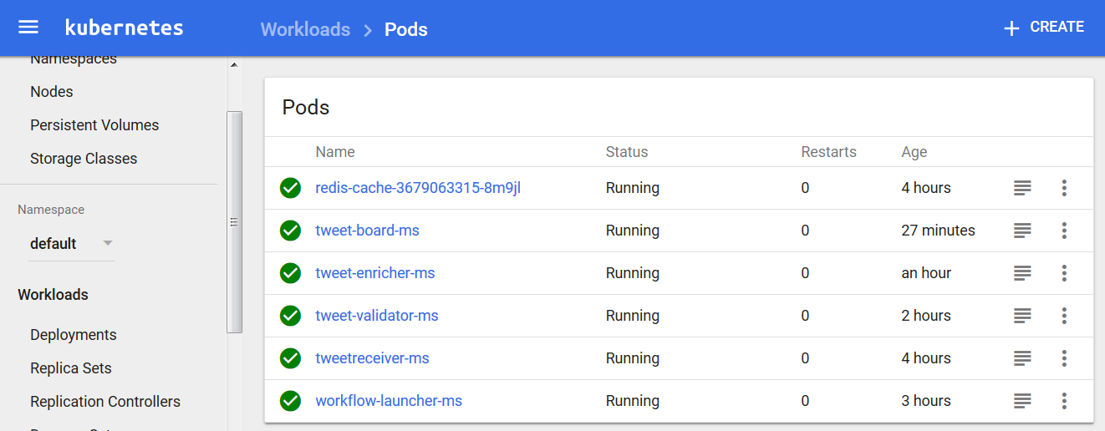

Inspect the port assigned to this microservice using *kubectl get services*. Then access the microservice at http://<docker machine IP>:<assigned port>/tweetBoard. You will not yet see any tweets on the tweet board.

However, as soon as you publish a valid tweet to the TweetReceiver micro service, the workflow is initiated and through the choreographed dance that involves Workflow Launcher, TweetValidator, TweetEnricher and TweetBoard, that tweet will make its appearance on the tweet board.

Publish a few tweets for TweetReceiver and inspect the tweet board again. You can use the test messages in the Postman collection:

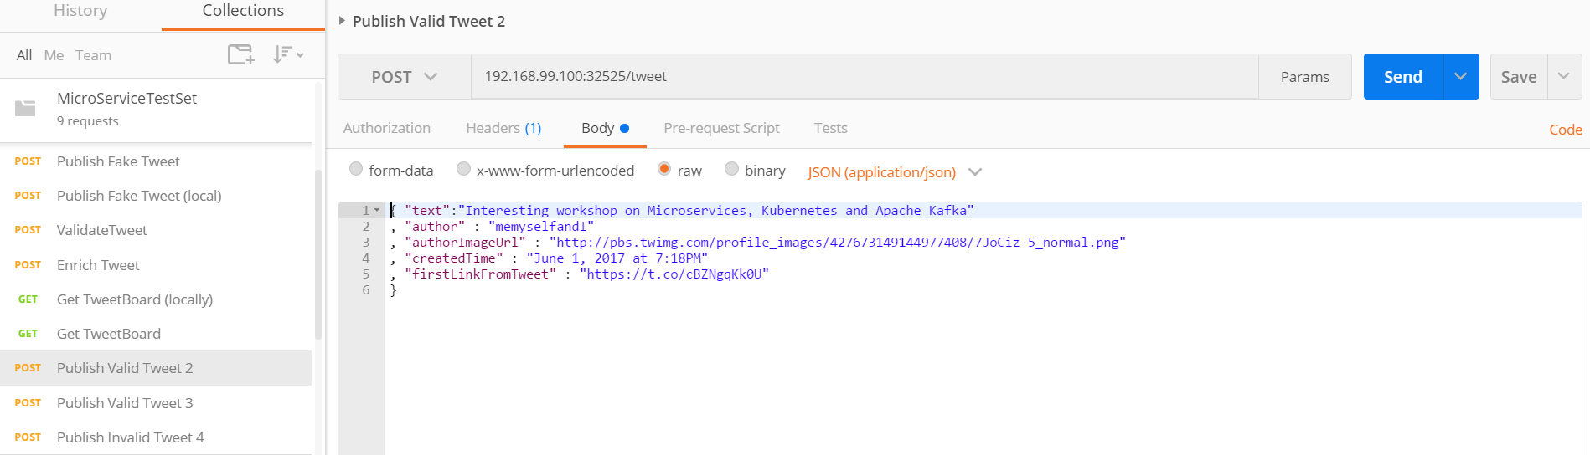

The Tweet Board looks like this:

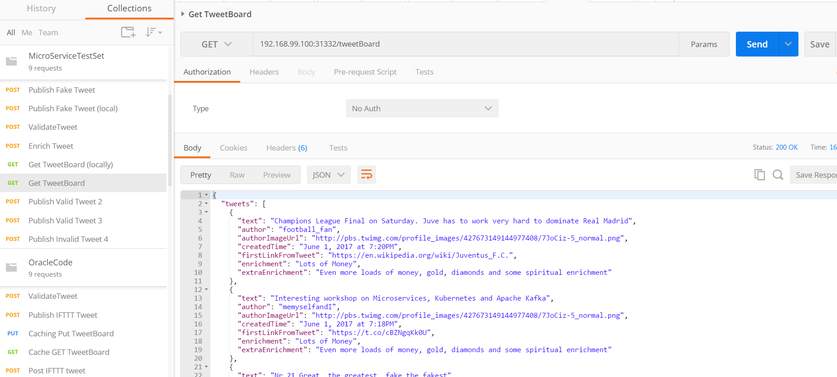

By checking the topic logTopic in the Kafka tool in the VM running Kafka, we get a feel for the workflows that were executed – and for tweets that did not get through validation:

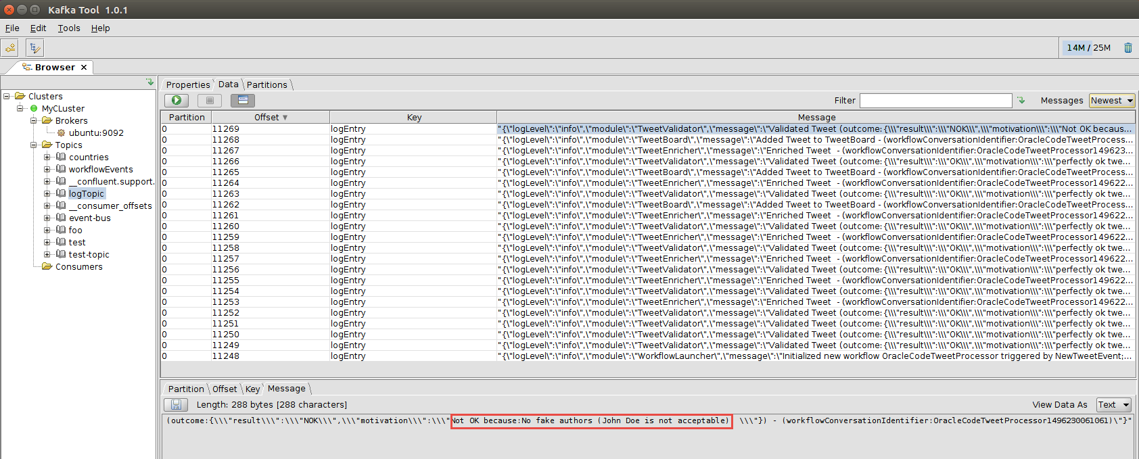

Note how you can filter events in this tool, for example by the workflow identifier:

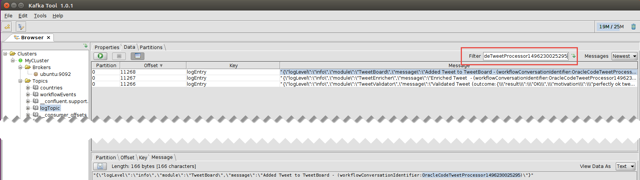

## Optional next steps Some obvious next steps around this workflow implementation and the microservices platform used are listed below:

* Expose TweetReceiver to the public internet (for example using ngrok) and create an IFTTT recipe to invoke the TweetReceiver for selected tweets; this allows the workflow to act on real tweets
* Run multiple instances (replicas) of the Pods that participate in the workflow (note: they are all stateless and capable of horizontally scaling; however, here is not currently any (optimistic) locking implemented on cache access, so race conditions are although rare still possible!)
* Change the workflow
  + create a new workflow plan that for example changes the sequence of validation and enrichment or even allows them to be in parallel (see example below)
  + add a step to the workflow (and a microservice to carry out that step)
* Create microservice (or simple Node.js script) to check the contents of Redis Cache (for example the tweetboard document or the payload for a specific workflow instance) (see example below)
* Retrieve Logging from Kafka Topic
* Run Kafka inside the Kubernetes cluster
* Implement one or more microservices on a cloud platform instead of on the local Kubernetes cluster; that requires use of an event bus on the cloud (e.g. Kafka on the cloud, such as CloudKarafka) and possibly (if the local Kafka is retained as well) a bridge between the local and the cloud based event bus.

### Inspect the cache contents

A simple cache inspector is available in directory part4/CacheInspector. You can run the node application CacheInspector.js locally, or you can launch another Pod on Kubernetes using   
  
kubectl create –f CacheInspectorPod.yaml –f CacheInspectorService.yaml

Using a URL like:  
192.168.99.100:32663/cacheEntry?key=OracleCodeTweetProcessor1496230025295

you can retrieve the workflow routing slip plus payload for a specific workflow instance. Of course you need to use your own IP address, assigned port and workflow identifier.

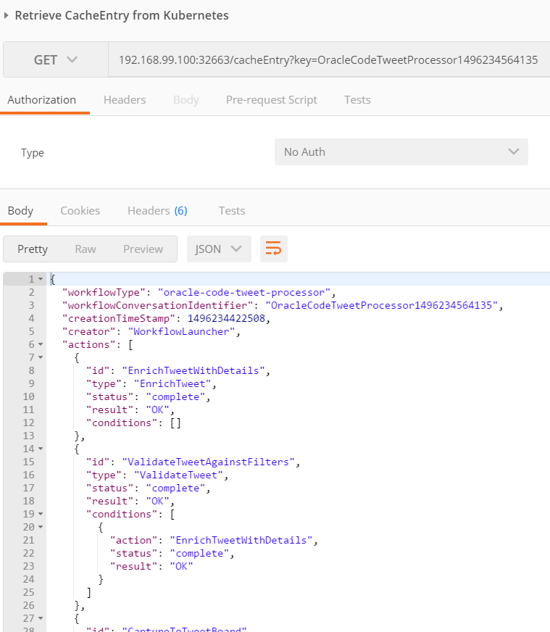

### Change the Workflow

A somewhat updated version of the Tweet Workflow is available in part4\WorkflowLauncher\ WorkflowLauncherV2.js. In this version, Enrichment is done before Validation. This is defined in the *message* variable at the bottom of the program.

You can force replace the pod currently running on Kubernetes for workflow-launcher-ms

kubectl replace -f WorkflowLauncherV2Pod.yaml --force

to try this later version of the workflow.

Publish a new tweet to TweetReceiver. Now when you inspect the logTopic on Kafka, the logs for the Kubernetes pods or the workflow document in the cache (through the CacheInspector) you will find that in the latest workflow, enrichment is done before validation.

# Appendix: Running Apache Kafka and Zookeeper in Docker and in Kubernetes

<https://howtoprogram.xyz/2016/07/21/using-apache-kafka-docker/>

Using the instructions at <http://docs.confluent.io/current/cp-docker-images/docs/quickstart.html> and working either directly in Docker or through Docker Quickstart Terminal (on Windows or MacOS), we can get Apache Kafka (and Zookeeper) running, in two separate Docker containers.

docker run -d \

--net=host \

--name=zookeeper \

-e ZOOKEEPER_CLIENT_PORT=32181 \

confluentinc/cp-zookeeper:3.2.1

docker run -d \

--net=host \

--name=kafka \

-e KAFKA_ZOOKEEPER_CONNECT=localhost:32181 \

-e KAFKA_ADVERTISED_LISTENERS=PLAINTEXT://localhost:29092 \

confluentinc/cp-kafka:3.2.1

docker run -d \

--net=host \

--name=schema-registry \

-e SCHEMA_REGISTRY_KAFKASTORE_CONNECTION_URL=localhost:32181 \

-e SCHEMA_REGISTRY_HOST_NAME=localhost \

-e SCHEMA_REGISTRY_LISTENERS=http://localhost:8081 \

confluentinc/cp-schema-registry:3.2.1

docker run -d \

--name=kafka-rest4 \

-p 8082:8082 \

-e KAFKA_REST_ZOOKEEPER_CONNECT=localhost:32181 \

-e KAFKA_REST_LISTENERS=http://localhost:8082 \

-e KAFKA_REST_SCHEMA_REGISTRY_URL=http://localhost:8081 \

-e KAFKA_REST_HOST_NAME=localhost \

confluentinc/cp-kafka-rest:3.2.1

docker inspect --format '{{ .NetworkSettings.IPAddress }}' kafka-rest

to get ip address to access REST Proxy?

Alternative:

https://howtoprogram.xyz/2016/07/21/using-apache-kafka-docker/

Based on <https://github.com/CloudTrackInc/kubernetes-kafka> - we get Apache Kafka running on our minikube cluster.

From directory part3/kubernetes-kafka:

Zookeeper

kubectl apply -f zoo-rc.yaml --record

This should start a Pod based on the digitalwonderland/zookeeper image for Apache Zookeeper (<https://github.com/digital-wonderland/docker-zookeeper>).

Next, expose this Pod as a Service:

kubectl apply -f zoo-service.yaml --record

Run ReplicationController for Kafka

kubectl apply -f kafka-rc.yaml –record

And expose this Pod as a service:

kubectl apply -f kafka-service.yaml

Kafka Rest Proxy

<https://hub.docker.com/r/confluentinc/cp-kafka-rest/>

Run Kafka Rest Proxy – listening at port 8082, connecting to Zookeeper and from there to Kafka broker

kubectl apply -f kafka-rest-proxy-rc.yaml

And to expose the REST proxy outside the cluster

kubectl apply -f kafka-rest-proxy-service.yaml

An overview of the three services now running to implement the Event Bus platform service:

kubectl get services

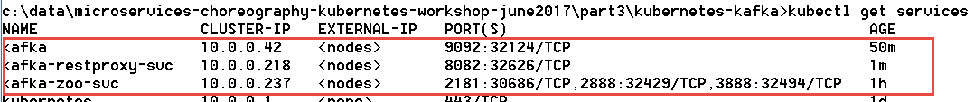

To try out the Event Bus configuration – we can ask the Kafka Rest Proxy for a list of topics available on the Kafka Cluster:

curl "http://192.168.99.100:32626/topics"

The response:



The fact that we get a response reveals that the Rest Proxy talked to Zookeeper and got in touch with the Kafka Broker. All three pods that constitute the Event Bus are in business.

curl "http://192.168.99.100:32626/topics/demo-topic"

In directory part3

kubectl apply -f kafka.yaml